Data Preprocessing Part 1

Data preprocessing is a vital step in machine learning that transforms raw, messy data into a clean and structured format for model training. It involves cleaning, transforming, encoding, and splitting data to improve model accuracy, prevent data leakage, and ensure compatibility with algorithms. While often confused with data cleaning, preprocessing encompasses a broader set of tasks critical to reliable machine learning pipelines. Using tools like Pandas, Scikit-learn, and Apache Spark helps streamline this process, making it scalable and effective across different project sizes and complexities.
What is data preprocessing in machine learning?
Data preprocessing in machine learning refers to the steps taken to clean, organize, and transform raw data into a format that machine learning algorithms can use effectively. Real-world data is often messy because it includes missing values, inconsistent formats, outliers, and irrelevant features. Without proper preprocessing, even the most sophisticated machine learning models can struggle to find patterns or may produce misleading results.
Effective data preprocessing not only improves the accuracy and efficiency of ML models but also helps uncover deeper insights hidden within the data. It sets the foundation for any successful ML project by ensuring the input data is high quality, consistent, and relevant.
Data preprocessing vs. data cleaning
While data preprocessing and data cleaning are often used interchangeably, they refer to different stages in the data preparation pipeline. Data cleaning is actually a subset of the broader data preprocessing process. Understanding the differences between the two is crucial to building reliable machine learning models, as each plays a unique role in preparing raw data for analysis. The table below clarifies their specific purposes, tasks, and importance.
Aspect | Data Cleaning | Data Preprocessing
Scope | Narrow – focuses on removing data issues | Broad – includes cleaning, transforming, and preparing data for machine learning
Main Goal | Improve data quality | Make data suitable for model training and evaluation
Typical Tasks | Removing duplicates, handling missing values | Cleaning, normalization, encoding, feature engineering, and splitting
Involves Transformation? | Rarely | Frequently (e.g., scaling, encoding, aggregation)
Used In | Data wrangling, early analysis | Full machine learning pipeline – from raw data to model-ready format
Tools Used | Pandas, OpenRefine, Excel | Scikit-learn, Pandas, TensorFlow, NumPy
Example | Filling in missing values with the mean | Filling in missing values and one-hot encoding, along with standardization and train/test split
Why data preprocessing is important in machine learning
Effective data preprocessing is a critical step in the machine learning pipeline. It ensures that the data fed into a model is clean, consistent, and informative, directly impacting its performance and reliability. Here are some key reasons why data preprocessing is important in machine learning:

  - Improves model accuracy: Clean and well-structured data enables algorithms to learn patterns more effectively, leading to better predictions and outcomes.
  - Reduces noise and inconsistencies: Removing irrelevant or erroneous data helps prevent misleading insights and model confusion.
  - Handles missing or incomplete data: Preprocessing techniques such as imputation or deletion ensure that gaps in data don’t degrade model performance.
  - Ensures data compatibility: Many machine learning algorithms require data in specific formats; preprocessing steps like normalization or encoding make the data compatible with these requirements.
  - Prevents data leakage: Proper data splitting during preprocessing (into training, validation, and test sets) helps avoid overfitting and ensures fair model evaluation.
  - Saves time and resources: Clean, organized data streamlines model training, reduces computational costs, and shortens development cycles.
Data preprocessing techniques
Data preprocessing involves various techniques designed to prepare raw data for use in machine learning models. Each technique addresses specific challenges in the dataset and contributes to cleaner, more reliable inputs. Below are some of the most commonly used data preprocessing techniques:

  - Data cleaning: Detects and corrects errors, removes duplicates, and handles missing values through strategies like imputation or deletion.
  - Encoding categorical variables: Converts non-numeric data (e.g., labels or categories) into numeric formats using one-hot encoding or label encoding.
  - Outlier detection and removal: Identifies data points that deviate significantly from others, which can negatively impact model performance if left unaddressed.
  - Dimensionality reduction: Reduces the number of input features while preserving important information, using methods like principal component analysis (PCA).
  - Normalization and scaling (Data Transformation and scaling): Adjusts numeric values to a common scale without distorting differences in the ranges, often essential for algorithms like KNN or gradient descent-based models.
  - Data splitting: Divides the dataset into training, validation, and test sets to evaluate the model effectively and prevent overfitting.
Data preprocessing steps in machine learning
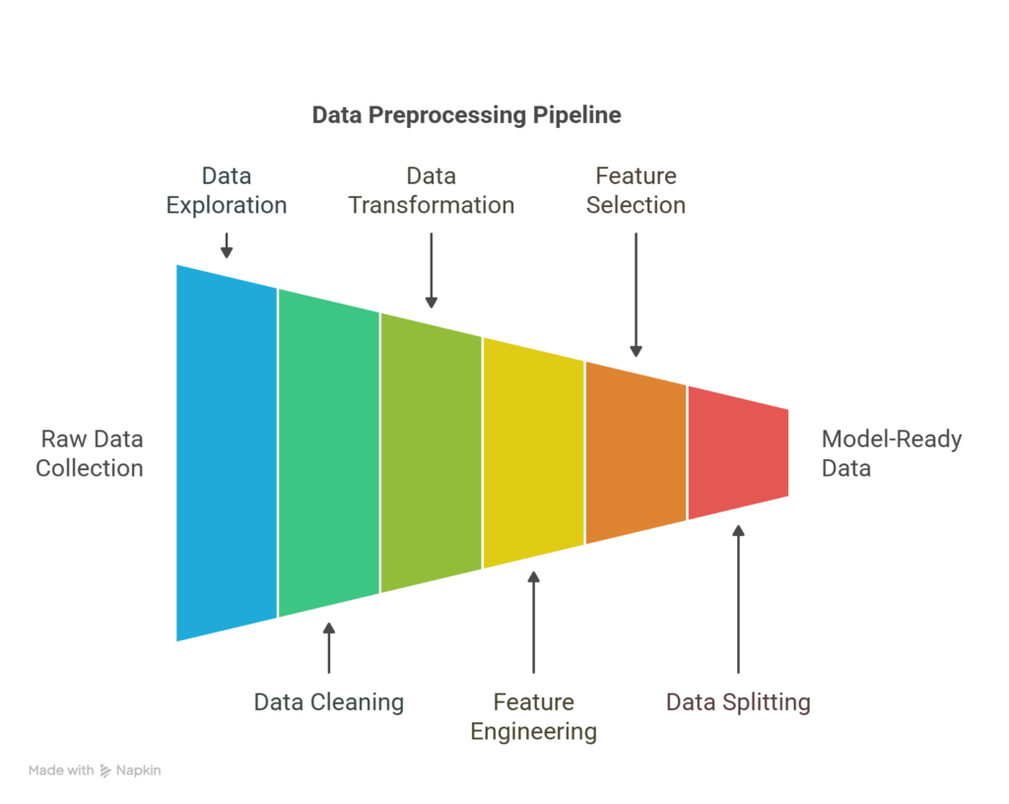
Steps in the data preprocessing pipeline
Data preprocessing is a multi-step process that prepares raw data for machine learning. Each step helps ensure the dataset is accurate, consistent, and optimized for model performance. Here’s a step-by-step breakdown of the typical data preprocessing workflow:
Data collection
The process begins with gathering data from relevant sources such as databases, APIs, sensors, or files. The quality and relevance of collected data directly influence the success of downstream tasks.
Data exploration
Before making changes, it’s essential to understand the dataset through exploratory data analysis (EDA). This step involves summarizing data characteristics, visualizing distributions, detecting patterns, and identifying anomalies or inconsistencies.
Data cleaning
This step addresses missing values, duplicate records, inconsistent formatting, and outliers. Cleaning ensures the dataset is reliable and free of noise or errors that could interfere with model training.
Data transformation
At this stage, the data is formatted for model compatibility. This process includes normalizing or scaling numerical values, encoding categorical variables, and transforming skewed distributions to improve model learning.
Feature engineering
New features are created based on existing data to better capture underlying patterns. This process might include extracting time-based variables, combining fields, or applying domain knowledge to enrich the dataset.
Feature selection
Not all features contribute equally to model performance. This step involves selecting the most relevant variables and removing redundant or irrelevant ones, which helps reduce overfitting and improve efficiency.
Data splitting
The cleaned and engineered dataset is divided into training, validation, and test sets. Doing this ensures that the model is evaluated on unseen data and generalizes to real-world scenarios.
Final review
Before modeling, a final check ensures that all preprocessing steps were correctly applied. This stage involves verifying distributions, feature quality, and data splits to prevent issues like data leakage or imbalance.
Data preprocessing example
Suppose you’re building a model to predict whether a customer will churn from a subscription service. Imagine you have a dataset from a telecom company with the following columns:
Customer_ID | Age | Gender | Monthly_Charges | Contract_Type | Churn
1 | 34 | Male | 70.5 | Month-to-month | Yes
2 | NaN | Female | 85 | One year | No
3 | 45 | Female | NaN | Month-to-month | Yes
4 | 29 | Male | 65.5 | Two year | No
Let’s walk through the preprocessing steps:
  - Handling missing values
    - Fill in the missing Age with the average age (36).
    - Fill in the missing Monthly_Charges with the column median (73.5).
  - Encoding categorical variables
    - Gender (Male/Female) and Contract_Type (Month-to-month, One year, Two year) are categorical.
    - Apply:
      - Label encoding for Gender (Male = 0, Female = 1)
      - One-hot encoding for Contract_Type, resulting in:
        - Contract_Month_to_month, Contract_One_year, Contract_Two_year

  - Feature scaling
    - Normalize Age and Monthly_Charges to bring them to the same scale (this is especially useful for distance-based models like KNN).
  - Target encoding
    - Convert Churn (Yes/No) to binary:
      - Yes = 1
      - No = 0
  - Cleaned and preprocessed dataset
Age | Gender | Monthly_Charges | Contract_Month | Contract_One | Contract_Two | Churn
34 | 0 | 70.5 | 1 | 0 | 0 | 1
36 | 1 | 85 | 0 | 1 | 0 | 0
45 | 1 | 73.5 | 1 | 0 | 0 | 1
29 | 0 | 65.5 | 0 | 0 | 1 | 0
Now the dataset is clean, numeric, and ready for model training.

Data preprocessing tools
Choosing the right tools for data preprocessing can impact the effectiveness of your machine learning workflow. Below is a list of commonly used tools, along with their strengths and limitations:
Pandas (Python)
Best suited for:
  - Handling structured data (e.g., CSVs, Excel, SQL tables)
  - Data cleaning, filtering, and transformation
  - Quick exploratory data analysis
Not suited for:
  - Large-scale distributed processing
  - Complex ETL pipelines or unstructured data (e.g., images, audio)
NumPy (Python)
Best suited for:
  - Numerical operations and handling multidimensional arrays
  - Performance-optimized matrix computations
Not suited for:
  - High-level data manipulation or cleaning
  - Working directly with labeled datasets (Pandas is more appropriate)
Scikit-learn (Python)
Best suited for:
  - Feature scaling, encoding, and selection
  - Data splitting (train/test/validation)
  - Integration with ML models and pipelines
Not suited for:
  - Deep learning tasks
  - Heavy data manipulation (use with Pandas)
OpenRefine
Best suited for:
  - Cleaning messy, unstructured, or inconsistent data
  - Reconciling and transforming data from different sources
  - Non-programmers needing a GUI-based tool
Not suited for:
  - Large datasets
  - Integration into automated machine learning workflows
Apache Spark (with PySpark or Scala)
Best suited for:
  - Processing large-scale datasets in a distributed environment
  - Data preprocessing in big data pipelines
  - Integration with cloud platforms (AWS, Azure, GCP)
Not suited for:
  - Small-to-medium datasets (overhead may not be justified)
  - Fine-grained, interactive data manipulation
Dataiku
Best suited for:
  - End-to-end ML workflows, including preprocessing, modeling, and deployment
  - Teams with both technical and non-technical users
  - Visual programming and automation
Not suited for:
  - Deep customization or low-level data control
  - Lightweight personal projects or code-only workflows

TensorFlow Data Validation (TFDV)
Best suited for:
  - Validating data pipelines in production ML workflows
  - Detecting schema anomalies and data drift at scale
  - Use within the TensorFlow Extended (TFX) ecosystem
Not suited for:
  - General-purpose data cleaning
  - Use outside TensorFlow or TFX environments
The strengths and limitations of these tools ultimately depend on the size of your project, the complexity, and the technical environment. Combining tools (e.g., Pandas for cleaning and Scikit-learn for feature scaling) usually provides the best results.

Data cleaning

This step addresses missing values, duplicate records, inconsistent formatting, and outliers. Cleaning ensures the dataset is reliable and free of noise or errors that could interfere with model training.

- Handle Missing Values:
Handling missing values is a crucial step in data preprocessing. In Python, several libraries offer different tools for this. Here's a detailed guide to the most commonly used libraries and their use cases, along with when and why to use each.

🧰 Libraries for Handling Missing Values in Python
1. pandas
✅ Use Case:
- Simple or exploratory data analysis (EDA)
- Direct manipulation of DataFrames
🛠️ Common Methods:
- df.isnull() / df.notnull() — detect missing values
- df.dropna() — remove missing values
- df.fillna(value) — fill with constants, mean, forward fill (method='ffill'), etc.
- df.ffill(inplace=False, limit=None)
- df.bfill(inplace=False, limit=None)
- df.isnull().sum()
- df.isnull().tail(50)
- df.notna()
- df.isna()
- df.where(df.notnull()
- df.replace(0, np.nan, inplace=True)
- df.replace([np.nan,0],1.0, inplace=True)
- df.fillna(1.0, inplace=True)
- df[df.isnull().any(axis=1)]
- df.T.fillna(df.median(axis=1), inplace=False).T
- df = df.mask((df < 0.4) & (df > 0),np.nan)
- df = df.mask( (df > 0.5) & (df < 1), np.nan)

💡 When to Use:
- Quick fixes during EDA (Exploratory Data Analysis)
- Easy data inspection
- Situations where you don’t need scikit-learn Pipelines

import pandas as pd
import numpy as np

df = pd.DataFrame({
'age': [25, np.nan, 30],
'salary': [50000, 60000, np.nan]
})

# Fill NaNs with column mean
df['age'] = df['age'].fillna(df['age'].mean())
df['salary'] = df['salary'].fillna(df['salary'].mean())

print(df)

2. sklearn.impute (scikit-learn)
✅ Use Case:
- Building ML pipelines
- Need for consistent preprocessing in training and testing data
🛠️ Tools:
- SimpleImputer: fills missing values using strategies like mean, median, most frequent, constant
- KNNImputer: uses K-nearest neighbors for imputation
- IterativeImputer: multivariate imputation using models
- MissingIndicator: adds binary features to indicate where values were missing
💡 When to Use:
- During model training and deployment
- When you want to include imputation as part of a pipeline
- When data needs more sophisticated imputation (e.g., correlated features)

Explain SimpleImputer:

SimpleImputer is a scikit-learn class which is helpful in handling the missing data in the predictive model dataset. It replaces the NaN values with a specified placeholder.
It is implemented by the use of the SimpleImputer() method which takes the following arguments :
missing_values : The missing_values placeholder which has to be imputed. By default is NaN
strategy : The data which will replace the NaN values from the dataset. The strategy argument can take the values - 'mean'(default), 'median', 'most_frequent' and 'constant'.
fill_value : The constant value to be given to the NaN data using the constant strategy.
Code: Python code illustrating the use of SimpleImputer class.
import numpy as np

# Importing the SimpleImputer class
from sklearn.impute import SimpleImputer
# Imputer object using the mean strategy and
# missing_values type for imputation
imputer = SimpleImputer(missing_values = np.nan,
strategy ='mean')
data = [[12, np.nan, 34], [10, 32, np.nan],
[np.nan, 11, 20]]
print("Original Data : \n", data)
# Fitting the data to the imputer object
imputer = imputer.fit(data)
# Imputing the data
data = imputer.transform(data)

print("Imputed Data : \n", data)

Output
Original Data :

[[12, nan, 34]
[10, 32, nan]
[nan, 11, 20]]

Imputed Data :

[[12, 21.5, 34]
[10, 32, 27]
[11, 11, 20]]
Remember: The mean or median is taken along the column of the matrix

Code example with different strategies –

# 1. SimpleImputer with mean strategy
mean_imputer = SimpleImputer(strategy='mean', missing_values=np.nan)
df_mean_imputed = df.copy()
transformed_data = mean_imputer.fit_transform(df_mean_imputed.iloc[:, :-1])
df_mean_imputed.iloc[:, :-1] = transformed_data
print("\nDataFrame after mean imputation:")
print(df_mean_imputed.head())

# Explain me this mean stategy how it works step by step
# 1. Calculate the mean of each feature (column) in the dataset, ignoring the missing values.
# For example, for the 'plas' column, the mean is calculated as:
# mean_plas = (148 + 85 + 183 + 89 + 137 + 116 + 78 + 115 + 197 + 125 + 110 + 140 + 130 + 99 + 120 + 100 + 95 + 105 + 143 + 129) / 19 = 122.68
# (Note: The missing value is ignored in the calculation)
# 2. Replace the missing values in each feature with the calculated mean.
# For the 'plas' column, the missing value at index 0 is replaced with the mean value:
# df_mean_imputed.loc[0, 'plas'] = mean_plas = 122.68
# 3. Repeat the process for all features with missing values.

# iloc[:, :-1] means - select all rows and all columns except the last one (target variable 'class').
# 4. The final imputed DataFrame will have the missing values replaced with the mean of their respective columns.

# 2. SimpleImputer with median strategy
median_imputer = SimpleImputer(strategy='median')
df_median_imputed = df.copy()
df_median_imputed.iloc[:, :-1] = median_imputer.fit_transform(df_median_imputed.iloc[:, :-1])
print("\nDataFrame after median imputation:")
print(df_median_imputed.head())

# Explain me this median stategy how it works step by step
# 1. Calculate the median of each feature (column) in the dataset, ignoring the missing values.
# For example, for the 'plas' column, the median is calculated as:
# median_plas = 122.68 (the middle value when the values are sorted)
# (Note: The missing value is ignored in the calculation)
# 2. Replace the missing values in each feature with the calculated median.
# For the 'plas' column, the missing value at index 0 is replaced with the median value:

# 3. SimpleImputer with most frequent strategy
most_frequent_imputer = SimpleImputer(strategy='most_frequent')
df_most_frequent_imputed = df.copy()
df_most_frequent_imputed.iloc[:, :-1] = most_frequent_imputer.fit_transform(df_most_frequent_imputed.iloc[:, :-1])
print("\nDataFrame after most frequent imputation:")
print(df_most_frequent_imputed.head())

# Explain me this most frequent stategy how it works step by step
# 1. Calculate the most frequent value of each feature (column) in the dataset, ignoring the missing values.
# For example, for the 'plas' column, the most frequent value is calculated as:
# most_frequent_plas = 148 (the value that appears most often in the column)
# (Note: The missing value is ignored in the calculation)
# 2. Replace the missing values in each feature with the calculated most frequent value.

# 4. SimpleImputer with constant strategy
constant_imputer = SimpleImputer(strategy='constant', fill_value=0)
df_constant_imputed = df.copy()
df_constant_imputed.iloc[:, :-1] = constant_imputer.fit_transform(df_constant_imputed.iloc[:, :-1])
print("\nDataFrame after constant imputation:")
print(df_constant_imputed.head())

# Explain me this constant stategy how it works step by step
# 1. Replace all missing values in each feature (column) with a specified constant value (in this case, 0).
# For example, for the 'plas' column, the missing value at index 0 is replaced with 0:
# df_constant_imputed.loc[0, 'plas'] = 0
# 2. Repeat the process for all features with missing values

Difference between: fit() & transform() vs fit_transform() methods of imputer
imputer = imputer.fit(data)
data = imputer.transform(data)
vs.
python
CopyEdit
data = imputer.fit_transform(data)

🔹 1. imputer.fit(data)
This learns from the data.
- For example, if the strategy is 'mean', it computes the mean of each column (ignoring NaNs) and stores it internally.
- No transformation happens at this step — it's just learning what to do.
✅ Used when you want to separate the fitting and transforming steps — often useful in machine learning pipelines where you fit on training data and transform both train and test data.

🔹 2. imputer.transform(data)
This applies the learned transformation.
- Replaces the missing values in data using the statistics computed during .fit().
✅ You call this on new data (e.g., test data or validation set) using the same logic learned from training data.

🔹 Combined version: fit_transform(data)
python
CopyEdit
data = imputer.fit_transform(data)
- Equivalent to calling fit() followed by transform().
- Commonly used for training data, where you want to fit and transform in a single step.

Imputer with add_indicator=True to allow inverse_transform

# 8. SimpleImputer.inverse_transform
# Reverses the transformation applied by the SimpleImputer
print("\nInverse transform example:")
mean_imputer = SimpleImputer(strategy='mean', add_indicator=True)
transformed = mean_imputer.fit_transform(df.iloc[:, :-1]) # fit on input columns

original_data = mean_imputer.inverse_transform(transformed)
print(pd.DataFrame(original_data, columns=df.columns[:-1]).head()) # Display the original data without missing values

# 9. SimpleImputer.get_params
# Gets the hyperparameters of the SimpleImputer model
print("\nGet parameters of SimpleImputer:")
params = mean_imputer.get_params() # Get the hyperparameters of the SimpleImputer model
print(params)

# hyperparameters means the parameters that control the behavior of the SimpleImputer model.
# Hyperparameters include the strategy used for imputation (mean, median, most frequent, constant), the fill value (if applicable), and other settings that affect how the model processes the data.

# 10. SimpleImputer.set_params
# Sets the hyperparameters of the SimpleImputer model
print("\nSet parameters of SimpleImputer:")
mean_imputer.set_params(strategy='median')
print(mean_imputer)

- Explain KNNImputer: uses K-nearest neighbors for imputation

Handling missing data in data science and machine learning, is a crucial preprocessing step. The K-Nearest Neighbors (KNN) Imputer is a sophisticated technique used for imputing missing values by leveraging the relationships within the dataset. This article delves into the workings of the KNN Imputer, its implementation, and its advantages over traditional imputation methods.

What is K-Nearest Neighbors Imputer (KNN)?
The KNN Imputer is a multivariate imputation method that fills in missing values by considering the values of the nearest neighbors of the data point with missing values. Unlike univariate methods, which consider only one variable at a time, the KNN Imputer uses multiple variables, making it a more robust and reliable approach for estimating missing data.
How Does K-Nearest Neighbors Imputer Work?
The KNN Imputer operates on the principle of the K-Nearest Neighbors algorithm, which is widely used for classification and regression tasks. Here’s a step-by-step breakdown of how the KNN Imputer works:
- Distance Calculation: For each missing value, the KNN Imputer calculates the distance between the data point with missing values and all other data points in the dataset. The default distance metric used is the Euclidean distance, which is NaN-aware, meaning it can handle missing values without biasing the distance calculation.
- Identifying Neighbors: The algorithm identifies the 'k' nearest neighbors to the data point with the missing value. These neighbors are the data points with the smallest distance to the point with the missing value.
- Imputation: The missing value is imputed using the mean (or median) of the identified nearest neighbors. This approach ensures that the imputed value is influenced by the most similar data points, thereby maintaining the integrity of the dataset.
- Handling Multivariate Data: In multivariate datasets, the KNN Imputer considers all available features, making it more effective in capturing the underlying patterns and relationships between variables.

Example: Imputing Missing Values with KNN Imputer
Imagine you have a dataset with three features (X1,X2,X3)(X1​,X2​,X3​) and five observations:
Observation | X_1 | X_2 | X_3
1 | 2.0 | 1.0 | 3.0
2 | 3.0 | 2.0 | 4.0
3 | NaN | 1.5 | 5.0
4 | 5.0 | 3.5 | 6.0
5 | 4.0 | NaN | 4.5
Here, "NaN" represents missing values.
Step 1: Identify the Missing Values
Let's say you want to impute the missing value in X_1​ for Observation 3.
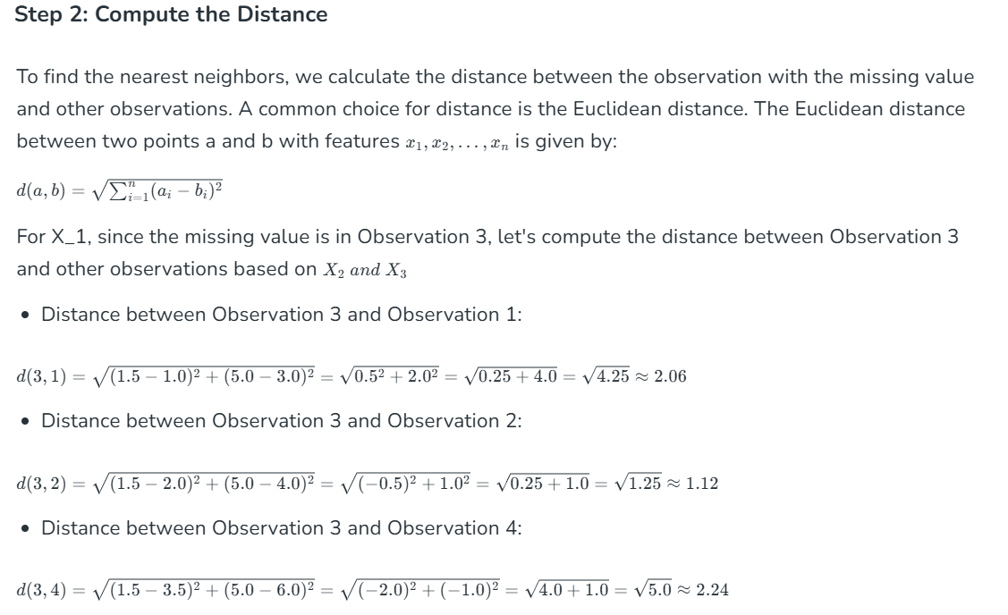
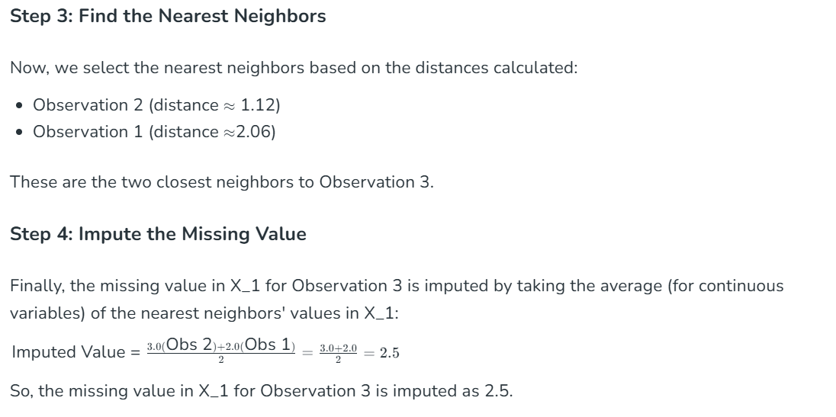
Let’s proof with 5 column

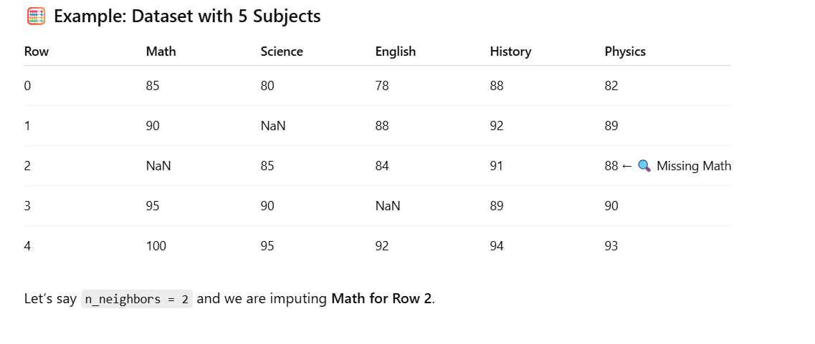
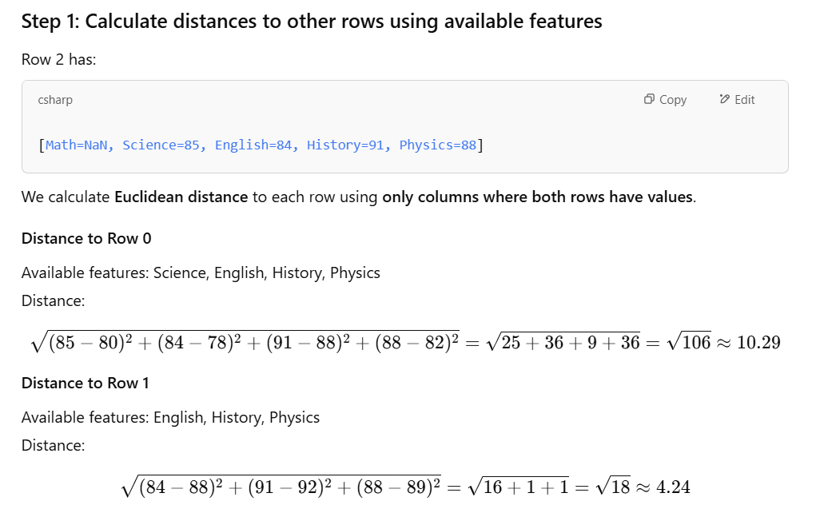
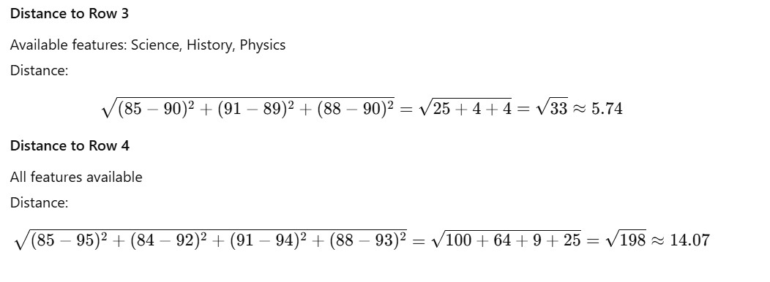
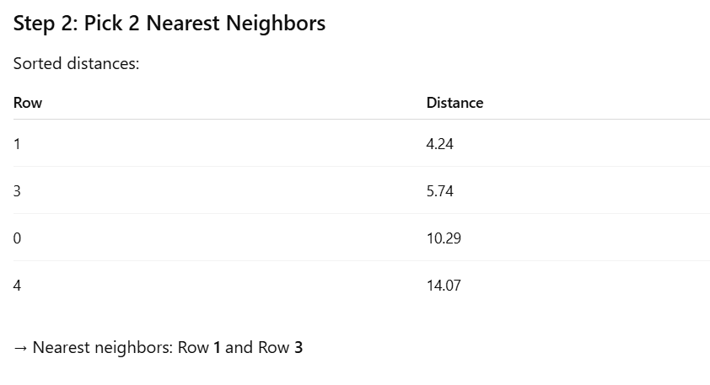
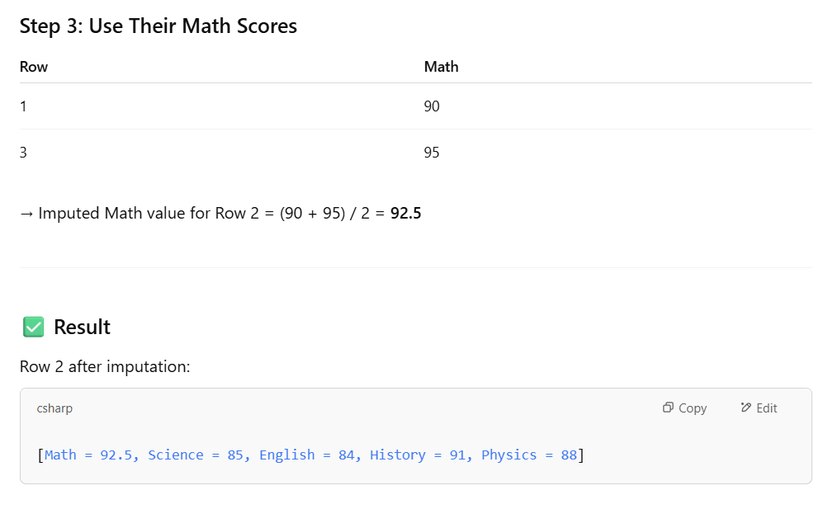
📌 Key Points
- Only shared non-NaN features are used for computing distances.
- Distance influences how similar the rows are.
- More features → more accurate proximity comparisons.
- You can also use weights='distance' to give more importance to closer neighbors.
Would you like the Python code version of this with KNNImputer?

Summary
Mathematically, the KNN Imputer works by:
- Calculating distances between the observation with missing data and all other observations (using available features).
- Selecting the nearest neighbors based on these distances.
- Imputing the missing value by averaging (or voting, in case of categorical data) the values of the nearest neighbors for the feature with the missing data.
Advantages of KNN Imputer
- Multivariate Approach: By considering multiple variables, the KNN Imputer provides a more comprehensive estimation of missing values compared to univariate methods.
- Flexibility: The method can be customized by choosing different distance metrics and the number of neighbors (k) based on the dataset's characteristics.
- Preservation of Data Integrity: By using similar data points for imputation, the KNN Imputer helps preserve the original distribution and relationships within the dataset.
Challenges and Considerations with KNN Imputer
While the KNN Imputer offers several advantages, there are some challenges and considerations to keep in mind:
- Computational Complexity: The method can be computationally expensive, especially for large datasets, as it involves calculating distances between all data points.
- Choice of 'k': Selecting the appropriate number of neighbors (k) is crucial. A small k might lead to overfitting, while a large k might smooth out important variations.
- Handling Categorical Data: The KNN Imputer is primarily designed for numerical data. Imputing categorical data requires additional preprocessing or alternative strategies.

Multivariate Analysis
Definition:
Analysis involving two or more variables simultaneously to explore relationships or patterns between them.
Purpose:
To examine how variables interact with each other (e.g., correlation, causation, or dependency).
Example Use Cases:
- How income and education affect spending behavior
- Relationship between features in a dataset before training a model
- Feature correlation heatmaps
Techniques:
- Plots: Scatter plots, Heatmaps, Pair plots, 3D plots
- Stats: Correlation, Covariance, Multiple Regression

Univariate Analysis
Definition:
Analysis involving only one variable (feature) at a time.
Purpose:
To understand the distribution, central tendency (mean, median, mode), and spread (variance, standard deviation) of a single variable.
Example Use Cases:
- Histogram of age distribution in a population
- Boxplot of product prices
- Frequency of a categorical variable (like gender)
Techniques:
- Plots: Histogram, Boxplot, Bar chart, Pie chart
- Stats: Mean, Median, Mode, Standard Deviation
- Summary Table:
Feature | Univariate | Multivariate
Variables involved | One | Two or more
Goal | Understand distribution | Understand relationships
Visualization | Histogram, Boxplot | Scatter plot, Heatmap
Examples | Distribution of Age | Age vs Income, Features vs Target
Use in ML | Outlier/scale detection | Feature correlation & interaction

Code example –
# import necessary libraries
import numpy as np
import pandas as pd

# import the KNNimputer class
from sklearn.impute import KNNImputer

# create dataset for marks of a student
dict = {'Maths': [80, 90, np.nan, 95],
'Chemistry': [60, 65, 56, np.nan],
'Physics': [np.nan, 57, 80, 78],
'Biology': [78, 83, 67, np.nan]}

# creating a data frame from the list
Before_imputation = pd.DataFrame(dict)
# print dataset before imputation
print("Data Before performing imputation\n", Before_imputation)

# create an object for KNNImputer
imputer = KNNImputer(n_neighbors=2)
After_imputation = imputer.fit_transform(Before_imputation)
# print dataset after performing the operation
print("\n\nAfter performing imputation\n", After_imputation)

Output:
Data Before performing imputation
Maths Chemistry Physics Biology
0 80.0 60.0 NaN 78.0
1 90.0 65.0 57.0 83.0
2 NaN 56.0 80.0 67.0
3 95.0 NaN 78.0 NaN
After performing imputation
[[80. 60. 68.5 78. ]
[90. 65. 57. 83. ]
[87.5 56. 80. 67. ]
[95. 58. 78. 72.5]]
Note: After transforming the data becomes a numpy array.

How KNN Imputer handles categorical data:
1. Scikit-learn's KNNImputer does not support categorical data directly.
It works only with numerical arrays, so if your dataset has categorical features, you must first encode them.

✅ Steps to handle categorical data in KNN Imputation
Step 1: Encode Categorical Variables
- You can use Ordinal Encoding (not One-Hot Encoding, because it creates many sparse features).
- Use sklearn.preprocessing.OrdinalEncoder.
Step 2: Apply KNNImputer
- Fit the imputer on the encoded dataset.
- It will impute missing values based on nearest neighbors.
Step 3: Reverse the encoding (optional)
- After imputation, convert back to the original category labels using .inverse_transform().

📌 Important Note
KNN treats encoded values as numbers, so use ordinal encoding only if there's an inherent order (e.g., low, medium, high). If not, this may introduce bias.
For nominal data (no order), consider using different imputation strategies like:
- SimpleImputer(strategy='most_frequent')
- Or use libraries like fancyimpute (older support for categorical KNN-like imputation).

✅ Example Code
python
CopyEdit
import pandas as pd
import numpy as np
from sklearn.impute import KNNImputer
from sklearn.preprocessing import OrdinalEncoder

# Sample data with categorical column
data = pd.DataFrame({
'Age': [25, 30, np.nan, 22, 40],
'Gender': ['Male', 'Female', 'Female', np.nan, 'Male']
})

# Step 1: Encode categorical
encoder = OrdinalEncoder()
data_encoded = data.copy()
data_encoded[['Gender']] = encoder.fit_transform(data[['Gender']])

# Step 2: Apply KNN imputer
imputer = KNNImputer(n_neighbors=2)
data_imputed = imputer.fit_transform(data_encoded)

# Step 3: Convert back to original categories
data_imputed = pd.DataFrame(data_imputed, columns=data.columns)
data_imputed[['Gender']] = encoder.inverse_transform(data_imputed[['Gender']])

print("\nData after KNN Imputation with categorical column:")
print(data_imputed)

🔍 Output (example):
nginx
CopyEdit
Age Gender
0 25.0 Male
1 30.0 Female
2 28.0 Female
3 22.0 Female
4 40.0 Male

KNNImputer code examples with different strategies
ChatGPT said:
The KNNImputer in scikit-learn is a powerful tool that fills in missing values using the K-Nearest Neighbors algorithm. It imputes missing values by finding the k nearest rows (using Euclidean distance) and then averaging their values for the missing feature.

✅ Key Parameters of KNNImputer
- n_neighbors: Number of nearest neighbors to use.
- weights:
  - 'uniform': All neighbors have equal weight.
  - 'distance': Closer neighbors get more weight.
- metric: Distance metric (default is 'nan_euclidean').

📘 Libraries to Import
python
CopyEdit
import numpy as np
import pandas as pd
from sklearn.impute import KNNImputer

📌 Sample DataFrame with Missing Values
python
CopyEdit
df = pd.DataFrame({
'Feature1': [1, 2, np.nan, 4, 5],
'Feature2': [3, np.nan, 1, 2, np.nan],
'Feature3': [5, 3, 4, np.nan, 2]
})
print("Original DataFrame:\n", df)

✅ Example 1: KNNImputer with Default Strategy
python
CopyEdit
imputer = KNNImputer(n_neighbors=2) # Default weights='uniform'
df_imputed = imputer.fit_transform(df)
print("\nImputed with uniform weights:\n", pd.DataFrame(df_imputed, columns=df.columns))

✅ Example 2: KNNImputer with weights='distance'
python
CopyEdit
imputer_distance = KNNImputer(n_neighbors=2, weights='distance')
df_imputed_dist = imputer_distance.fit_transform(df)
print("\nImputed with distance-based weights:\n", pd.DataFrame(df_imputed_dist, columns=df.columns))

✅ Example 3: KNNImputer with More Neighbors
python
CopyEdit
imputer_3 = KNNImputer(n_neighbors=3)
df_imputed_3 = imputer_3.fit_transform(df)
print("\nImputed with 3 neighbors:\n", pd.DataFrame(df_imputed_3, columns=df.columns))

🧠 How It Works
For each missing value:
- Finds the k nearest rows (with non-missing values in that column).
- Computes the average (or weighted average) of the feature from those neighbors.
- Replaces the missing value with that average.

- Explain IterativeImputer: multivariate imputation using models

Introduction to Missing Data Imputation
Missing data imputation involves replacing missing values with estimated ones. This process is essential because most machine learning algorithms cannot handle missing values directly. There are various imputation methods, ranging from simple techniques like mean or median imputation to more complex model-based methods.
Multivariate feature imputation is a method used to fill in missing data in a dataset. Instead of just looking at one column or feature at a time, it considers the relationships between different features to make better guesses about the missing values. This approach uses the information from multiple columns to predict what the missing data should be, resulting in more accurate and reliable imputation.
IterativeImputer: An Overview
The IterativeImputer is a multivariate imputation algorithm implemented in scikit-learn. It is based on the concept of iterative imputation, where the imputation process is repeated multiple times, with each iteration refining the estimates of the missing values. The algorithm uses a round-robin approach, where each feature is imputed in turn, using the current estimates of the other features.
How IterativeImputer Works?
The IterativeImputer algorithm can be broken down into the following steps:
- Initialization: The algorithm starts by initializing the missing values with a random or mean imputation.
- Feature Selection: The algorithm selects a feature to impute, typically in a round-robin fashion.
- Imputation: The selected feature is imputed using a regression model, which predicts the missing values based on the observed values of the other features.
- Update: The imputed values are updated, and the process is repeated for the next feature.
- Convergence: The algorithm continues until convergence, which is typically determined by a stopping criterion such as a maximum number of iterations or a tolerance threshold.
Implementing IterativeImputer in Scikit-learn
Key Parameters of IterativeImputer: The IterativeImputer algorithm has several key parameters that can be tuned for optimal performance:
- max_iter: The maximum number of iterations for the imputation process.
- tol: The tolerance threshold for convergence.
- n_nearest_features: The number of nearest features to use for imputation.
- initial_strategy: The initial imputation strategy, which can be either 'mean' or 'median'.
Choosing the Right Estimator
The IterativeImputer allows the use of different estimators to model the missing values. Common choices include:
- BayesianRidge: A linear regression model with Bayesian regularization.
- DecisionTreeRegressor: A non-linear model that can capture complex relationships.
- ExtraTreesRegressor: An ensemble method that averages multiple decision trees.
- KNeighborsRegressor: A non-parametric method that uses the nearest neighbors to estimate missing values.

Advantages and Limitations of IterativeImputer
Advantages:
- Accuracy: By considering the relationships between features, multivariate imputation can provide more accurate estimates than univariate methods.
- Flexibility: The IterativeImputer can be used with various estimators, allowing for customization based on the specific dataset.
Limitations:
- Computationally Intensive: Iterative imputation can be computationally expensive, especially for large datasets with many features.
- Complexity: The method involves multiple iterations and the choice of estimator, which can add complexity to the preprocessing pipeline.
Practical Considerations
When using IterativeImputer, consider the following practical tips:
- Scaling: Ensure that the features are appropriately scaled, as some estimators may be sensitive to the scale of the data.
- Convergence: Monitor the convergence of the imputation process. If the imputations do not converge, consider increasing the number of iterations or changing the estimator.
- Validation: Validate the imputation results using cross-validation or other evaluation methods to ensure that the imputed values are reasonable.

Dataset: Diabetes (from sklearn)
We’ll use the built-in diabetes dataset and introduce some missing values manually.
Step 1: Setup and Create Missing Data

import numpy as np
import pandas as pd
from sklearn.datasets import load_diabetes
from sklearn.experimental import enable_iterative_imputer
from sklearn.impute import IterativeImputer

# Load real dataset
data = load_diabetes()
X_full = pd.DataFrame(data.data, columns=data.feature_names)

# Introduce some missing values
rng = np.random.default_rng(42)
X_missing = X_full.copy()
missing_mask = rng.choice([True, False], size=X_missing.shape, p=[0.1, 0.9])
X_missing[missing_mask] = np.nan

print("Missing data summary:\n", X_missing.isnull().sum())

Step 2: Apply Iterative Imputer

# Initialize IterativeImputer (uses BayesianRidge by default)
imputer = IterativeImputer(max_iter=5, random_state=0)

# Fit and transform the data
X_imputed = imputer.fit_transform(X_missing)

# Convert back to DataFrame
X_imputed_df = pd.DataFrame(X_imputed, columns=X_full.columns)

# Compare before and after
print("\nOriginal with missing values (first 5 rows):")
print(X_missing.head())

print("\nImputed values (first 5 rows):")
print(X_imputed_df.head())
Step-by-Step Internals
- Initialization:
Each missing value is initially filled using mean (or median).
- Iterative Modeling (Loop for max_iter=5):
For each feature (column) with missing values:
  - Use all other features as input XXX
  - Use the feature with missing data as target yyy
  - Fit a regression model (default: BayesianRidge) on rows without missing target
  - Predict the missing values using the model and update
- Repeat the above for all columns with missing data, one round = 1 iteration.
- Convergence:
After several rounds, imputed values stop changing significantly.

🔍 You Can Also Customize the Model
python
CopyEdit
from sklearn.linear_model import LinearRegression

imputer = IterativeImputer(estimator=LinearRegression(), max_iter=10, random_state=0)
This uses simple linear regression instead of the Bayesian Ridge model.

- Explain MissingIndicator: adds binary features to indicate where values were missing

What is MissingIndicator?
MissingIndicator is a transformer in scikit-learn that generates a binary matrix indicating the location of missing values (np.nan) in your dataset.
It's especially useful when you want to keep track of where the original missing values were — for example, when training models that can use missingness as a signal.

🔍 Why Use It?
- Some models benefit from knowing which values were missing (e.g., tree-based models).
- When you impute data, the missing information is lost. MissingIndicator preserves that information.
- Can be used alone or combined with imputation.

🛠️ How It Works
For input matrix XXX:
- Output matrix has the same number of rows as XXX.
- Each column in the output corresponds to a column in XXX with missing values.
- Values in the output are 1 where data is missing and 0 otherwise.

🧪 Code Example
python
CopyEdit
import numpy as np
import pandas as pd
from sklearn.impute import MissingIndicator

# Example dataset
X = np.array([
[1, 2, np.nan],
[4, np.nan, 6],
[7, 8, 9],
[np.nan, 11, 12]
])

# Initialize the indicator
indicator = MissingIndicator()

# Fit and transform
missing_mask = indicator.fit_transform(X)

print("Original Data:\n", X)
print("\nMissing Indicator Output:\n", missing_mask)

🔍 Output Explanation
plaintext
CopyEdit
Original Data:
[[ 1. 2. nan]
[ 4. nan 6.]
[ 7. 8. 9.]
[nan 11. 12.]]

Missing Indicator Output:
[[0. 0. 1.]
[0. 1. 0.]
[0. 0. 0.]
[1. 0. 0.]]
- Each 1 indicates a missing value in the original data.
- Only columns with at least one missing value are included in the output.

🔧 Use With Imputers (Pipeline)
You can combine MissingIndicator with an imputer in a pipeline to retain information about missingness:

from sklearn.pipeline import FeatureUnion
from sklearn.impute import SimpleImputer

# Create imputer and indicator
imputer = SimpleImputer(strategy='mean')
indicator = MissingIndicator()

# Combine both
combined = FeatureUnion([
('imputer', imputer),
('missing_indicator', indicator)
])

X_combined = combined.fit_transform(X)
print("Combined Output:\n", X_combined)
This creates a feature matrix where:
- First columns are imputed data.
- Extra columns at the end are the missing value indicators.

✅ Summary
Concept | Details
Purpose | Flag missing values with 0/1 (binary) mask
Input | Any dataset with missing values (np.nan)
Output | Binary matrix with same number of rows, fewer columns
Typical Use Case | Combined with imputers to keep track of original missing locations
Advantage | Models may learn useful patterns from "missingness" itself

Used With Imputers
The MissingIndicator is almost always paired with one of the following imputation transformers:
Imputer | Purpose
SimpleImputer | Fills missing values with mean, median, mode, etc.
KNNImputer | Fills missing values based on nearest neighbors
IterativeImputer | Predicts missing values using regression models
➕ Why add MissingIndicator?
Even after filling in values, some models benefit from knowing which values were originally missing — this is where MissingIndicator adds value.

- Handling duplicate records:

Handling duplicate records is a key step in data cleaning. While pandas is the primary library used, there are other libraries and tools that complement it when working with more complex deduplication logic (e.g., fuzzy matching, record linkage). Here's a detailed breakdown:

🧰 Libraries to Handle Duplicate Records in Python
1. pandas – The Primary Tool
✅ Use Case:
- Quick identification and removal of exact duplicate rows
- Manipulating DataFrames during EDA or preprocessing
🛠️ Key Methods:
- df.duplicated()
→ Returns boolean Series indicating duplicate rows.
- df.drop_duplicates()
→ Removes duplicate rows.
- df[df.duplicated(keep=False)]
→ Filters only duplicates (useful for inspection).
🔍 Options:
- subset: Limit check to certain columns.
- keep: 'first', 'last', or False to keep no duplicates.
💡 When to Use:
- Most use cases when duplicates are exactly matching
- Simple, fast, and works out-of-the-box

2. recordlinkage – For Fuzzy Deduplication

What is recordlinkage?
recordlinkage is a Python toolkit for:
- Deduplication: Identify and merge duplicate records in a single dataset.
- Record linkage: Match records across different datasets that refer to the same entity.
- Fuzzy matching: Use approximate string comparison to find close (but not exact) matches.

✅ Use Cases
Use Case | Description
Customer deduplication | Match duplicate customers (e.g., "Jon Smith" vs "John Smith")
Dataset merging | Merge overlapping data from different sources
Fuzzy joins | Join tables with slightly mismatched text fields
Data cleaning | Detect and merge variations in spelling, typos, etc.

📦 Types of Comparisons Available
Method | Description
Exact | Exact string or number match
String | Approximate string match using Jaro, Levenshtein, etc.
Numeric | Numeric differences (absolute or relative)
Date | Difference in days
Geographic | Compare geolocations (latitude/longitude)
Custom | You can write your own matching logic

🧰 Sample Dataset: Before Deduplication

import pandas as pd

# Sample data with possible duplicates
data = pd.DataFrame({
'name': ['John Smith', 'Jon Smith', 'Jane Doe', 'J. Doe', 'Alice Johnson'],
'dob': ['1990-01-01', '1990-01-01', '1985-07-15', '1985-07-15', '1992-03-22'],
'city': ['New York', 'NYC', 'San Francisco', 'SF', 'Los Angeles']
})

⚙️ Deduplication with recordlinkage
🔹 Step 1: Setup and Indexing

import recordlinkage

# Create an indexer object and use blocking (e.g., on dob)
indexer = recordlinkage.Index()
indexer.block('dob')
candidate_links = indexer.index(data)
🔹 Step 2: Compare Pairs
# Create a Compare object
compare = recordlinkage.Compare()

# Add comparison methods
compare.string('name', 'name', method='jarowinkler', label='name_similarity')
compare.string('city', 'city', method='jarowinkler', label='city_similarity')

# Compute similarity scores
features = compare.compute(candidate_links, data)
print(features)
🔹 Step 3: Classify Matches
# You can use a threshold or classifier
# Simple threshold for fuzzy match
matches = features[features.sum(axis=1) > 1.5]
print(matches)

📝 Output: Matched Duplicates
You’ll see matched pairs of indexes that are likely duplicates:

MultiIndex([
(0, 1), # 'John Smith' ~ 'Jon Smith'
(2, 3), # 'Jane Doe' ~ 'J. Doe'
])

✅ After Deduplication (Manually remove duplicates)
duplicate_indexes = set(i for pair in matches.index for i in pair)
deduped_data = data.drop(index=duplicate_indexes - {min(pair) for pair in matches.index})

print(deduped_data)

📊 Before vs After Example
📌 Before:
Index | Name | DOB | City
0 | John Smith | 1990-01-01 | New York
1 | Jon Smith | 1990-01-01 | NYC
2 | Jane Doe | 1985-07-15 | San Francisco
3 | J. Doe | 1985-07-15 | SF
4 | Alice Johnson | 1992-03-22 | Los Angeles
📌 After:
Index | Name | DOB | City
0 | John Smith | 1990-01-01 | New York
2 | Jane Doe | 1985-07-15 | San Francisco
4 | Alice Johnson | 1992-03-22 | Los Angeles

🧠 Matching Algorithms You Can Use
Method | Available in | Description
exact() | Compare | Direct match
string() | Compare | Fuzzy match (Jaro, Levenshtein, etc.)
numeric() | Compare | Difference tolerance
date() | Compare | Date delta
geo() | Compare | Haversine distance
custom() | Compare | Use your own function

🔚 Summary
- recordlinkage allows powerful fuzzy deduplication.
- Uses approximate string matching, date comparison, etc.
- Works for single-table (deduplication) or two-table (record linkage).
- You control matching logic with flexible comparators

//////////////////////////////////

Scenario: Match customer records from two different sources
🔧 Step-by-step with Code:
📦 Step 1: Install the library
pip install recordlinkage

📊 Step 2: Sample DataFrames (Data from two sources)
import pandas as pd

# Dataset A (source1)
df_a = pd.DataFrame({
'name': ['John Smith', 'Jane Doe', 'Alice Johnson'],
'dob': ['1990-01-01', '1985-07-15', '1992-03-22'],
'city': ['New York', 'San Francisco', 'Los Angeles']
}, index=['a1', 'a2', 'a3'])

# Dataset B (source2)
df_b = pd.DataFrame({
'name': ['Jon Smith', 'J. Doe', 'Alicia Johnson'],
'dob': ['1990-01-01', '1985-07-15', '1992-03-22'],
'city': ['NYC', 'SF', 'LA']
}, index=['b1', 'b2', 'b3'])

🔍 Step 3: Indexing (Candidate Pairs)
import recordlinkage
indexer = recordlinkage.Index()
indexer.block('dob') # Only compare rows with same DOB
candidate_links = indexer.index(df_a, df_b)

🔍 Step 4: Compare the Fields
compare = recordlinkage.Compare()
compare.string('name', 'name', method='jarowinkler', threshold=0.85, label='name_similarity')
compare.string('city', 'city', method='jarowinkler', threshold=0.85, label='city_similarity')
features = compare.compute(candidate_links, df_a, df_b)

print(features)

✅ Step 5: Identify Matches

# Simple rule-based classifier: match if both similarities > threshold
matches = features[features.sum(axis=1) >= 2]
print("Matched Pairs:")
print(matches)

🔚 Output: Matched Pairs
You will see something like:
Matched Pairs:
name_similarity city_similarity
a1 b1 1.0 0.92
a2 b2 0.94 0.90
This means:
- a1 (John Smith) matched b1 (Jon Smith)
- a2 (Jane Doe) matched b2 (J. Doe)

🧠 Optional: Use ML Classifier for Matching

from recordlinkage.algorithms.classifier import ECMClassifier
ecm = ECMClassifier()
ecm.fit(features) # Unsupervised classifier
matches = ecm.predict(features)
print("Matches by ECMClassifier:")
print(matches)

compare.string('name', 'name', method='jarowinkler', label='name_similarity')
compare.string('city', 'city', method='jarowinkler', label='city_similarity')
✅ Purpose:
This method is used to compare string fields (like name or city) between two datasets to compute a similarity score.

🔍 Syntax:
compare.string(left_on, right_on, method='jarowinkler', threshold=None, label=None, missing_value=0.0)
🧠 Parameter-by-parameter Explanation:
Parameter Description
left_on Column name in the left dataset (e.g., df_a)
right_on Column name in the right dataset (e.g., df_b)
method Similarity function to use. Options include:

'jarowinkler' (default and good for names)
'levenshtein'
'damerau_levenshtein'
'cosine'
'jaccard'
'smith_waterman' |
| threshold | Minimum similarity score (0.0 to 1.0) to return 1; otherwise, it returns a score between 0 and 1. If None, it returns a continuous score |
| label | Column name for the output comparison result (used in the features DataFrame) |
| missing_value | Value to return if one or both values are missing. Default is 0.0 |

✅ Example:
compare.string('name', 'name', method='jarowinkler', label='name_similarity')
This does the following:

Compare the 'name' column in both df_a and df_b
Use Jaro-Winkler similarity (which is good for short strings and names)
No hard threshold – it will return a similarity score between 0 and 1
Result column will be labeled 'name_similarity'

🔢 Example Similarity Scores:
Name A Name B Score (Jaro-Winkler)
John Smith Jon Smith 0.93
Alice Johnson Alicia Johnson 0.89
Jane Doe Janet Do 0.76

🔁 With Threshold:
compare.string('name', 'name', method='jarowinkler', threshold=0.85, label='name_match')
If similarity ≥ 0.85, it returns 1
Otherwise, it returns 0

So the result becomes a binary decision instead of a score.

✅ Summary Table:
Param | Type | Required | Default | Purpose
left_on | str | ✅ | — | Left column name
right_on | str | ✅ | — | Right column name
method | str | ❌ | 'jarowinkler' | Similarity method
threshold | float | ❌ | None | Binary threshold (if needed)
label | str | ❌ | None | Output column name
missing_value | float | ❌ | 0.0 | Value to return if value is missing

3. fuzzywuzzy / thefuzz (successor)
What is fuzzywuzzy / thefuzz?
thefuzz is a string matching library that uses Levenshtein distance behind the scenes. It offers high-level scoring functions that make it easy to apply fuzzy matching to strings, especially for:
- Name matching
- Address deduplication
- Record linkage
- Search/autocomplete
- NLP preprocessing
It's not a new algorithm, but a convenience wrapper around Levenshtein-based similarity metrics.

🔧 Core Scoring Methods (with Use Cases)
1. fuzz.ratio
- Use case: Basic character-level similarity.
- How it works: Levenshtein distance normalized to [0, 100].
- Best for: Clean, similarly structured strings.
Example:
fuzz.ratio("data science", "data scince") → 96

2. fuzz.partial_ratio
- Use case: Match short string within longer one.
- How it works: Finds best partial match (substring) between the two.
- Best for: Partial input in autocomplete or short-to-long comparison.
Example:
fuzz.partial_ratio("machine", "machine learning") → 100

3. fuzz.token_sort_ratio
- Use case: Match strings with reordered words.
- How it works: Tokenizes strings, sorts them alphabetically, then applies ratio.
Example:
python
CopyEdit
fuzz.token_sort_ratio("red apple", "apple red") → 100

4. fuzz.token_set_ratio
- Use case: Ignore redundant words or order.
- How it works: Compares intersection and symmetric difference of word sets.
Example:
python
CopyEdit
fuzz.token_set_ratio("apple orange banana", "banana apple apple") → 100

5. process.extract() and process.extractOne()
- Use case: Find best matches from a list of strings.
- Best for: Autocomplete, search, deduplication.
Example:
from thefuzz import process
process.extract("jon smyth", ["john smith", "jane doe", "jonathan smith"])
# [('john smith', 91), ('jonathan smith', 86), ('jane doe', 0)]

✅ Comparison with Other Algorithms
Feature | thefuzz.ratio | partial_ratio | token_sort_ratio | token_set_ratio | Best For
Basic similarity | ✅ | ✅ | ✅ | ✅ | General fuzzy matching
Word reordering | 🚫 | 🚫 | ✅ | ✅ | Names, addresses, phrases
Substring handling | 🚫 | ✅ | 🚫 | 🚫 | Abbreviations, partial input
Redundant word ignore | 🚫 | 🚫 | 🚫 | ✅ | Repeated words, synonyms
Token-based | 🚫 | 🚫 | ✅ | ✅ | Multi-word comparisons

💡 Summary
Method | Good For | Handles Word Order? | Handles Redundancy? | Handles Substrings?
fuzz.ratio | Clean, short strings | ❌ | ❌ | ❌
fuzz.partial_ratio | Partial/abbreviated matches | ❌ | ❌ | ✅
fuzz.token_sort_ratio | Reordered phrases | ✅ | ❌ | ❌
fuzz.token_set_ratio | Reordered + redundant words | ✅ | ✅ | ✅ (indirectly)
process.extract | Finding best matches from list

import pandas as pd
from thefuzz import fuzz
from thefuzz import process

# Create sample DataFrames
df_a = pd.DataFrame({
'name': ['Jon Smyth', 'Alice Johnson', 'Robert Brown', 'Maria Garcia'],
'city': ['New York', 'Los Angeles', 'Chicago', 'Miami'],
'dob': ['1985-02-10', '1990-05-14', '1987-08-22', '1993-03-11'],
'email': ['jon.s@example.com', 'alice.j@example.com', 'robert.b@example.com', 'maria.g@example.com']
})

df_b = pd.DataFrame({
'name': ['John Smith', 'Alicia Jonson', 'Rob Brown', 'Maria Garcia'],
'city': ['NYC', 'Los Angeles', 'Chicago', 'Miami'],
'dob': ['1985-02-10', '1990-05-14', '1987-08-22', '1993-03-11'],
'email': ['john.s@example.com', 'alicia.j@example.com', 'rob.b@example.com', 'maria.g@example.com']
})

# Function to compute fuzzy match scores
def compute_fuzzy_scores(row_a, row_b):
return {
'name_score': fuzz.token_sort_ratio(row_a['name'], row_b['name']),
'city_score': fuzz.token_sort_ratio(row_a['city'], row_b['city']),
'dob_match': row_a['dob'] == row_b['dob'], # exact match
'email_match': row_a['email'] == row_b['email'] # exact match
}

# Compare each row in df_a with each row in df_b
matches = []
for idx_a, row_a in df_a.iterrows():
for idx_b, row_b in df_b.iterrows():
scores = compute_fuzzy_scores(row_a, row_b)
if scores['name_score'] >= 80 and scores['dob_match']:
matches.append({
'df_a_index': idx_a,
'df_b_index': idx_b,
'name_a': row_a['name'],
'name_b': row_b['name'],
'name_score': scores['name_score'],
'city_score': scores['city_score'],
'dob_match': scores['dob_match'],
'email_match': scores['email_match']
})

# Show matched records
matched_df = pd.DataFrame(matches)
print(matched_df)

the code I shared performs a manual pairwise comparison between every row in df_a and every row in df_b, resulting in a kind of comparison matrix. This is commonly referred to as a Cartesian product join, which becomes computationally expensive as data grows.
To make it more efficient and less manual, especially for large datasets, you typically use a record linkage library like recordlinkage or dedupe, which:
- Blocks similar records to reduce comparisons (e.g., only compare rows with the same date of birth).
- Vectorizes string comparisons to avoid loops.
- Provides classifiers (e.g., logistic regression) to decide if two records match.

🔄 Manual Approach vs Efficient Record Linkage
Feature | Manual Comparison (as shown) | recordlinkage Library
Approach | Loops through all combinations | Uses indexing and blocking
Speed | Slow for large data | Efficient and scalable
Matching Logic | Hardcoded | Model-based or rule-based
Reusability | Low | High

✅ If you want to make it smarter:
We can refactor the logic to use the recordlinkage framework — which creates a comparison vector for each candidate pair, applies blocking/indexing, and uses distance metrics like Jaro-Winkler or Levenshtein, all vectorized.

4. dask
✅ Use Case:
- Parallelized version of pandas for large-scale data
🛠️ Methods:
- dask.dataframe.drop_duplicates(), duplicated()
💡 When to Use:
- When you’re working with very large datasets
- Similar API to pandas but scales better

What is Dask?
Dask is a parallel computing library that extends pandas, NumPy, and scikit-learn to work with big data across multiple cores or even clusters — while still using familiar syntax.
It’s often used for:
- Scalable data preprocessing
- Distributed machine learning
- Faster ETL pipelines
- Efficient parallelized fuzzy matching

🔍 Dask for Record Linkage (Fuzzy Matching at Scale)
Although Dask doesn’t have built-in fuzzy matching, it can be combined with fuzzywuzzy or RapidFuzz to parallelize the pairwise comparisons — avoiding memory bottlenecks in large datasets.

✅ Example Workflow
Let’s go through an example where we perform fuzzy matching between two large DataFrames using Dask and RapidFuzz (faster than thefuzz).
🔧 Install Requirements
bash
CopyEdit
pip install dask[complete] rapidfuzz

🧪 Example Code
python
CopyEdit
import dask.dataframe as dd
import pandas as pd
from rapidfuzz import fuzz

# Sample data
df_a = pd.DataFrame({
'name': ['Jon Smyth', 'Alice Johnson', 'Robert Brown', 'Maria Garcia'],
'city': ['New York', 'Los Angeles', 'Chicago', 'Miami']
})

df_b = pd.DataFrame({
'name': ['John Smith', 'Alicia Jonson', 'Rob Brown', 'Maria Garcia'],
'city': ['NYC', 'Los Angeles', 'Chicago', 'Miami']
})

# Convert to Dask DataFrames
ddf_a = dd.from_pandas(df_a, npartitions=2)
ddf_b = dd.from_pandas(df_b, npartitions=2)

# Create cross join using merge (cartesian product)
ddf_a['key'] = 1
ddf_b['key'] = 1
joined = ddf_a.merge(ddf_b, on='key', suffixes=('_a', '_b')).drop('key', axis=1)

# Define fuzzy comparison function
def fuzzy_match(row):
return pd.Series({
'name_score': fuzz.token_sort_ratio(row['name_a'], row['name_b']),
'city_score': fuzz.token_sort_ratio(row['city_a'], row['city_b'])
})

# Apply the function row-wise (must convert back to pandas for UDF)
result = joined.map_partitions(lambda df: df.apply(fuzzy_match, axis=1))

# Combine original joined data with match scores
final = dd.concat([joined, result], axis=1)

# Filter for good matches
matches = final[(final['name_score'] > 80)].compute()
print(matches[['name_a', 'name_b', 'name_score', 'city_score']])

📈 Output
mathematica
CopyEdit
name_a name_b name_score city_score
0 Jon Smyth John Smith 91 67
1 Alice Johnson Alicia Jonson 86 100
2 Robert Brown Rob Brown 89 100
3 Maria Garcia Maria Garcia 100 100

🧰 Summary of Dask-Based Approach
Feature | Description
Scalable | Handles large datasets that don’t fit into memory
Parallelized | Automatically uses all available CPU cores
Flexible | Can use RapidFuzz, NumPy, or any custom function
Good for Fuzzy Join | When combined with distributed UDFs
Better than Pandas | For very large data and heavy preprocessing

Dask + Record Linkage: Distributed Fuzzy Deduplication
Although recordlinkage itself isn’t natively distributed, you can split your data into chunks using Dask, and apply record linkage logic in parallel.
✅ Use Case
- Massive customer datasets with potential duplicates
- Need to perform fuzzy match based on names/emails/etc.
🔧 Code Example
python
CopyEdit
import pandas as pd
import dask.dataframe as dd
import recordlinkage
from dask import delayed

# Create synthetic datasets
df = pd.DataFrame({
'name': ['Jon Smyth', 'John Smith', 'Alice Johnson', 'Alicia Jonson', 'Maria Garcia'],
'dob': ['1990-01-01', '1990-01-01', '1985-03-05', '1985-03-05', '1992-07-10']
})

# Convert to Dask DataFrame
ddf = dd.from_pandas(df, npartitions=2)

# Define delayed record linkage function
@delayed
def find_duplicates(df_chunk):
indexer = recordlinkage.Index()
indexer.block('dob') # Only compare same DOB
candidate_links = indexer.index(df_chunk)

compare = recordlinkage.Compare()
compare.string('name', 'name', method='jarowinkler', label='name_sim')
features = compare.compute(candidate_links, df_chunk)

return features[features['name_sim'] > 0.85]

# Apply to each partition
results = [find_duplicates(part.compute()) for part in ddf.partitions]
final_result = dd.from_delayed(results).compute()
print(final_result)
✅ Output
Fuzzy-duplicate matches across partitions.

🤖 2. Dask + Autoimpute: Distributed Missing Value Imputation
Autoimpute doesn’t natively support Dask yet, but you can partition data using Dask, impute within each partition using Pandas + Autoimpute, and then recombine.
🔧 Install
pip install autoimpute
✅ Code Example
import pandas as pd
import dask.dataframe as dd
from autoimpute.imputations import MeanImputer
from dask import delayed

# Create sample data with missing values
df = pd.DataFrame({
'age': [25, 30, None, 28, None, 35],
'salary': [50000, None, 52000, None, 48000, 55000]
})

# Convert to Dask
ddf = dd.from_pandas(df, npartitions=2)

# Define delayed imputation function
@delayed
def impute_chunk(chunk):
imputer = MeanImputer()
return imputer.fit_transform(chunk)

# Apply imputer to each partition
imputed_chunks = [impute_chunk(part.compute()) for part in ddf.partitions]
result_df = dd.from_delayed(imputed_chunks).compute()
print(result_df)
✅ Output
A DataFrame with missing values imputed using the mean for each column.

🔍 Summary Table
Feature | Dask + Recordlinkage | Dask + Autoimpute
Use Case | Deduplication/fuzzy matching | Missing value handling
Parallelization | By row-block + partitioning | By partitioning + custom imputation
Built-in Dask Support | ❌ (manual integration with delayed) | ❌ (manual integration with delayed)
Suitable for | Large datasets | Datasets with many NaNs
Libraries Involved | recordlinkage, dask | autoimpute, dask

5. datasketch
✅ Use Case:
- Probabilistic deduplication using MinHash and LSH
🛠️ Features:
- MinHash, MinHashLSH, ideal for near-duplicate document detection
💡 When to Use:
- For high-dimensional data or when deduplicating based on entire documents or paragraphs
- NLP or content-based deduplication

6. pyjanitor
✅ Use Case:
- Enhances pandas with more readable syntax
🛠️ Method:
- df.remove_duplicates(subset=..., keep=...)
💡 When to Use:
- You want cleaner syntax and additional chaining-friendly functionality

🧠 Summary: When to Use Which
Task | Best Tool
Simple row-wise deduplication | pandas
Large dataset, parallel processing | dask
String-based or fuzzy deduplication | thefuzz, recordlinkage
Deduplicating documents/content | datasketch
Cleaner, chainable pandas-style code | pyjanitor

Note - Scikit-learn (sklearn) does not provide direct functions to remove duplicate records in the way pandas does. This is because scikit-learn is a machine learning library focused on model training, transformation, and prediction—not on raw data wrangling or cleaning.
Why does scikit-learn (sklearn) handle missing values but not duplicates?
Aspect | Missing Values | Duplicate Records
🔍 Nature | Feature-level issue | Row-level (entire record) issue
🧠 Model relevance | Models can’t train on NaN values | Models can train on duplicates, but biased
🔧 Handling granularity | Needs imputation (mean, median, etc.) | Just remove or deduplicate entire rows
📦 sklearn Support | Yes: SimpleImputer, KNNImputer, etc. | ❌ Not in sklearn — use pandas

Why sklearn doesn't include duplicate removal:
- Duplicate handling is purely data hygiene, not model logic.
- It’s a one-time global operation, independent of modeling steps.
- It’s better done using tools like:
  - pandas.drop_duplicates()
  - Fuzzy matching libraries (e.g., fuzzywuzzy, recordlinkage)
- Including it in a pipeline could lead to unintended behavior, like deduplication during every cross-validation split.

✅ Summary:
Task | When to handle | Tool / Library
Remove duplicates | Before ML pipeline | pandas
Handle missing values | Inside ML pipeline | sklearn.impute

- Handle Inconsistent Formatting:

Inconsistent Formatting
🔍 What is it?
Inconsistent formatting refers to data entries that represent the same thing in different ways due to variations in:
- Capitalization
- Spelling
- Units
- Date/time formats
- Punctuation or whitespace

🧾 Examples:
Issue Type | Examples | Problem
Capitalization | "USA", "usa", "Usa" | Should be normalized to "USA"
Whitespace | "John", " John ", "john" | Should be "John"
Date Formats | "2024-01-01", "01/01/2024" | Ambiguous or inconsistent parsing
Units | "5kg", "5000g" | Different units, same measurement
Spelling Variants | "colour", "color" | British vs. American English

Ways to Handle Inconsistent Formatting in a DataFrame
🔹 1. Standardizing Text (Case, Spacing, Typos)
- Convert all text to lowercase or uppercase
- Strip whitespace
- Fix typos using fuzzy matching
📌 Example:
df['country'] = df['country'].str.strip().str.upper()
📚 Libraries:
- Pandas – for text manipulation (.str methods)
- FuzzyWuzzy / RapidFuzz – to match/fix similar strings
What is FuzzyWuzzy / RapidFuzz?
- FuzzyWuzzy was a Python library built on top of Levenshtein distance.
- RapidFuzz is a faster, more efficient alternative, with the same functionality but much better performance.
They are used for:
- Deduplication
- Auto-correct / typo correction
- Data cleaning (e.g., fixing name or address inconsistencies)

✨ Key String Matching Methods
1. ratio() — Basic Levenshtein similarity
Percentage similarity between two strings.
2. partial_ratio() — Ignores unmatched substrings
Useful if strings differ in length but contain the same essential words.
3. token_sort_ratio() — Ignores word order
Sorts the words alphabetically before comparison.
4. token_set_ratio() — Ignores duplicates and word order
Most forgiving, ideal when one string is a subset of another.

✅ Install RapidFuzz (recommended over FuzzyWuzzy)

pip install rapidfuzz

Example: Fuzzy Match Names
python
CopyEdit
from rapidfuzz import fuzz, process

name1 = "Jon Smith"
name2 = "John Smith"

print("Ratio:", fuzz.ratio(name1, name2))
print("Partial Ratio:", fuzz.partial_ratio(name1, name2))
print("Token Sort Ratio:", fuzz.token_sort_ratio(name1, name2))
print("Token Set Ratio:", fuzz.token_set_ratio(name1, name2))
🔎 Output
plaintext
CopyEdit
Ratio: 95.65
Partial Ratio: 100.0
Token Sort Ratio: 95.65
Token Set Ratio: 100.0

🧠 Auto-Correct / Best Match from List
python
CopyEdit
from rapidfuzz import process

names = ["Alice Johnson", "Alicia Jonson", "Bob Martin", "Jon Smyth"]
query = "John Smith"

# Get best match
match = process.extractOne(query, names, scorer=fuzz.token_set_ratio)
print("Best Match:", match)
✅ Output
sql
CopyEdit
Best Match: ('Jon Smyth', 86.67, 3)

🔄 Fuzzy Deduplication in a DataFrame
python
CopyEdit
import pandas as pd
from rapidfuzz import fuzz

data = pd.DataFrame({
'name': ['Jon Smith', 'John Smith', 'Alice Johnson', 'Alicia Jonson', 'Jon Smyth']
})

# Find duplicates with similarity > 85%
duplicates = []
for i in range(len(data)):
for j in range(i+1, len(data)):
score = fuzz.token_set_ratio(data.iloc[i]['name'], data.iloc[j]['name'])
if score > 85:
duplicates.append((data.iloc[i]['name'], data.iloc[j]['name'], score))

for a, b, s in duplicates:
print(f"{a} <--> {b} : {s}")
🔎 Sample Output
lua
CopyEdit
Jon Smith <--> John Smith : 95.65
Jon Smith <--> Jon Smyth : 90.0
John Smith <--> Jon Smyth : 86.67
Alice Johnson <--> Alicia Jonson : 92.86

📚 Use Cases
Use Case | Method to Use
Auto-correct search input | process.extractOne()
Deduplication | fuzz.token_set_ratio
Fixing typos | fuzz.ratio
Data cleaning in names/addresses | token_sort_ratio or token_set_ratio

Core String Matching Functions
Method | Use Case | Description
fuzz.ratio(s1, s2) | General string similarity | Basic Levenshtein similarity (0–100)
fuzz.partial_ratio(s1, s2) | Match substrings | Great when one string is a subset of the other
fuzz.token_sort_ratio(s1, s2) | Different word orders | Normalizes word order before comparing
fuzz.token_set_ratio(s1, s2) | Subset + word order insensitive | Ignores common words and order
fuzz.QRatio(s1, s2) | Quick similarity | Faster but slightly less accurate
fuzz.WRatio(s1, s2) | Weighted combination | Combines several methods, best for general use

🔍 Best-Match Search Functions
Method | Use Case | Description
process.extract(query, choices) | Top-N fuzzy matches | Returns list of best matches and scores
process.extractOne(query, choices) | Best single match | Returns best match and its score
process.cdist() | Vectorized matching | Compare all combinations (like distance matrix)

🔄 DataFrame Preprocessing Use Cases
Use Case | Method | Example
Standardize inconsistent category values | process.extractOne() | Normalize city names like "New York", "newyork", "N.Y."
Fuzzy deduplication (find near duplicates) | fuzz.token_sort_ratio() with loop over DataFrame | Group customer names like "Jon Smith", "john smith"
Grouping similar product names | process.extract() with threshold | Match "laptop", "Laptop", "Lap Top" as same group
Matching user input to canonical data | extractOne against known values | Match misspelled entries to valid labels (e.g., "smrtphone" → "Smartphone")
String distance matrix generation | cdist() | Advanced deduplication or clustering based on distances

Step-by-Step Code Example
import pandas as pd
from rapidfuzz import process, fuzz

# Sample DataFrame with inconsistent formatting
df = pd.DataFrame({
'Name': ['Jon Smith', 'john smith', 'J. Smith', 'Alice Johnson', 'Alicia Jonson'],
'City': ['New York', 'newyork', 'N.Y.', 'Los Angeles', 'LA'],
'Product': ['Laptop', 'laptop', 'LAPTOP', 'smart phone', 'Smartphone']
})

print("Original DataFrame:\n", df)

🎯 Step 1: Define a function to standardize using fuzzy match
We’ll create a function that maps values to their closest match in a known set of canonical values:
def standardize_column(column, choices, threshold=85):
return column.apply(
lambda x: process.extractOne(x, choices, scorer=fuzz.token_sort_ratio)[0]
if process.extractOne(x, choices, scorer=fuzz.token_sort_ratio)[1] >= threshold else x
)

🧹 Step 2: Standardize City and Product columns
python
CopyEdit
# Define canonical values
canonical_cities = ['New York', 'Los Angeles']
canonical_products = ['Laptop', 'Smartphone']

# Apply standardization
df['City_Standardized'] = standardize_column(df['City'], canonical_cities)
df['Product_Standardized'] = standardize_column(df['Product'], canonical_products)

📊 Final Output
python
CopyEdit
print("\nStandardized DataFrame:\n", df)
📋 Output Example:
sql
CopyEdit
Original DataFrame:
Name City Product
0 Jon Smith New York Laptop
1 john smith newyork laptop
2 J. Smith N.Y. LAPTOP
3 Alice Johnson Los Angeles smart phone
4 Alicia Jonson LA Smartphone

Standardized DataFrame:
Name City Product City_Standardized Product_Standardized
0 Jon Smith New York Laptop New York Laptop
1 john smith newyork laptop New York Laptop
2 J. Smith N.Y. LAPTOP New York Laptop
3 Alice Johnson Los Angeles smart phone Los Angeles Smartphone
4 Alicia Jonson LA Smartphone Los Angeles Smartphone

2. Date/Time Formatting
- Convert all dates to a standard format (datetime64)
- Handle different regional formats (MM/DD/YYYY vs DD/MM/YYYY)
📌 Example:

df['date'] = pd.to_datetime(df['date'], dayfirst=True, errors='coerce')
📚 Libraries:
- Pandas – pd.to_datetime
- Dateutil – advanced date parsing
- Arrow – easier date manipulation
✅ Use Case:
- Cleaning transaction logs, timestamps, etc.

1. Using pandas for Date/Time
✅ Common Use Cases:
- Parsing datetime from strings
- Changing datetime formats
- Extracting date components (year, month, etc.)
- Time series handling
🔧 Key Methods:
Method | Description
pd.to_datetime() | Convert string/object to datetime
dt.year, dt.month | Extract date parts
dt.strftime() | Format datetime to string
dt.normalize() | Remove time component (set time to 00:00:00)
✅ Example:
python
CopyEdit
import pandas as pd

df = pd.DataFrame({'date_str': ['2023-08-10', '10/08/2023', 'Aug 10, 2023']})
df['parsed_date'] = pd.to_datetime(df['date_str'])
df['year'] = df['parsed_date'].dt.year
df['formatted'] = df['parsed_date'].dt.strftime('%d-%b-%Y')

print(df)

📆 2. Using dateutil.parser for Flexible Parsing

✅ Common Use Cases:
- Parsing unknown or inconsistent date formats
- Automatically detecting date formats
🔧 Key Functions:
Function | Description
parser.parse() | Parse nearly any date string into datetime.datetime
parse(..., fuzzy=True) | Ignores non-date parts like text around date
✅ Example:

from dateutil import parser

dates = ['10 Aug 2023', '2023-08-10', 'Aug 10th, 2023']
parsed = [parser.parse(date) for date in dates]

for d in parsed:
print(d.strftime('%Y-%m-%d'))

🕒 3. Using arrow for Human-Friendly Time Manipulation
✅ Common Use Cases:
- Working with time zones
- Human-readable formatting
- Time shifting (add, subtract)
🔧 Key Methods:
Method | Description
arrow.get() | Parses string or timestamp
shift() | Add or subtract time
format() | Custom datetime formatting
humanize() | Outputs "3 days ago", "in 2 hours", etc.
✅ Example:

import arrow

# Parse a datetime
dt = arrow.get('2023-08-10T15:30:00')

# Format
print(dt.format('YYYY-MM-DD HH:mm'))

# Shift time
print(dt.shift(days=+5).format('YYYY-MM-DD'))

# Human-readable
print(dt.humanize(arrow.utcnow())) # e.g., "2 months ago"

1. Using pandas
python
CopyEdit
import pandas as pd

# Sample data
data = {
'name': ['Alice', 'Bob', 'Charlie'],
'signup_date': ['2023-08-10', '10/08/2023', 'Aug 9th, 2023'],
'last_login': ['Aug 15, 2023', '2023-08-16 14:30:00', '16th Aug 2023 16:00']
}

df = pd.DataFrame(data)

# Convert to datetime
df['signup_date'] = pd.to_datetime(df['signup_date'])
df['last_login'] = pd.to_datetime(df['last_login'])

# Extract year and weekday from signup_date
df['signup_year'] = df['signup_date'].dt.year
df['signup_day'] = df['signup_date'].dt.day_name()

# Format last_login to custom string
df['last_login_fmt'] = df['last_login'].dt.strftime('%d-%b-%Y %H:%M')

print(df)
🔹 Output:
yaml
CopyEdit
name signup_date last_login signup_year signup_day last_login_fmt
0 Alice 2023-08-10 2023-08-15 00:00:00 2023 Thursday 15-Aug-2023 00:00
1 Bob 2023-10-08 2023-08-16 14:30:00 2023 Sunday 16-Aug-2023 14:30
2 Charlie 2023-08-09 2023-08-16 16:00:00 2023 Wednesday 16-Aug-2023 16:00

✅ 2. Using dateutil.parser (for inconsistent formats)
python
CopyEdit
from dateutil import parser

# Parse individually using parser
df['parsed_signup'] = df['signup_date'].apply(lambda x: parser.parse(str(x)))
df['parsed_login'] = df['last_login'].apply(lambda x: parser.parse(str(x)))

print(df[['name', 'parsed_signup', 'parsed_login']])
🔹 Output:
yaml
CopyEdit
name parsed_signup parsed_login
0 Alice 2023-08-10 00:00:00 2023-08-15 00:00:00
1 Bob 2023-10-08 00:00:00 2023-08-16 14:30:00
2 Charlie 2023-08-09 00:00:00 2023-08-16 16:00:00

✅ 3. Using arrow (friendly formatting)
python
CopyEdit
import arrow

# Use Arrow for last login column
df['last_login_arrow_fmt'] = df['last_login'].apply(lambda x: arrow.get(x).format('dddd, MMMM D, YYYY HH:mm'))
df['last_login_human'] = df['last_login'].apply(lambda x: arrow.get(x).humanize(arrow.utcnow()))

print(df[['name', 'last_login_arrow_fmt', 'last_login_human']])
🔹 Output:
yaml
CopyEdit
name last_login_arrow_fmt last_login_human
0 Alice Tuesday, August 15, 2023 00:00 9 months ago
1 Bob Wednesday, August 16, 2023 14:30 9 months ago
2 Charlie Wednesday, August 16, 2023 16:00 9 months ago

✅ Summary Table of Use Cases
Task | pandas | dateutil | arrow
Structured Date Parsing | ✅ Excellent | ✅ Excellent | ✅ Good
Inconsistent Formats | ⚠️ Partial | ✅ Very Strong | ✅ Very Strong
Formatting Custom Output | ✅ Yes | ⚠️ Limited | ✅ Great (with format)
Time Manipulation | ✅ With Timedelta | ⚠️ Manual | ✅ Easy with shift()
Human-Readable Output | ❌ Not supported | ❌ Not supported | ✅ Yes (humanize())

3. Numeric Standardization (Units, Currency)
- Convert all measurements to a single unit (e.g., cm → m)
- Remove currency symbols or commas from strings before converting
📌 Example:
df['amount'] = df['amount'].str.replace('$', '').str.replace(',', '').astype(float)
📚 Libraries:
- Pandas
- Quantities / Pint – for unit conversions
✅ Use Case:
- Standardizing financial, scientific, or health-related data

Libraries Overview
1. pandas – for basic data handling and numerical operations
2. quantities (quantities or pint) – for physical unit conversions

✅ Sample Dataset (3 Columns)
import pandas as pd

data = {
'product': ['A', 'B', 'C'],
'length_inch': [10, 25, 50], # inches
'weight_lb': [2.2, 5.5, 11], # pounds
'price_eur': [10.5, 20.0, 15.75] # in euros
}

df = pd.DataFrame(data)
print(df)

✅ Using pint for Unit Standardization
import pint

# Create a UnitRegistry
ureg = pint.UnitRegistry()

# Apply conversions
df['length_cm'] = df['length_inch'].apply(lambda x: (x * ureg.inch).to(ureg.cm).magnitude)
df['weight_kg'] = df['weight_lb'].apply(lambda x: (x * ureg.pound).to(ureg.kilogram).magnitude)

# Assuming 1 EUR = 1.1 USD
df['price_usd'] = df['price_eur'] * 1.1

# Normalize prices between 0 and 1
df['price_usd_normalized'] = (df['price_usd'] - df['price_usd'].min()) / (df['price_usd'].max() - df['price_usd'].min())

print(df)

🔹 Output:
product length_inch weight_lb price_eur length_cm weight_kg price_usd price_usd_normalized
0 A 10 2.2 10.50 25.400000 0.997903 11.55 0.000000
1 B 25 5.5 20.00 63.500000 2.494757 22.00 1.000000
2 C 50 11.0 15.75 127.000000 4.989514 17.33 0.495749

✅ Useful Methods
Purpose | Method/Library | Description
Length, weight conversion | pint, quantities | Convert between physical units
Currency conversion | * exchange rate | Multiply with fixed or dynamic rate
Real-time currency rates | forex-python, currencyconverter | Fetch live exchange rates
Standardization (z-score) | sklearn.preprocessing.StandardScaler | Normalize to mean 0, std 1
Min-max scaling | (x - min) / (max - min) | Normalize range between 0–1
Decimal scaling | / 10^n | Normalize large numbers
Log scaling | np.log(), np.log1p() | Scale-down highly skewed data
Rounding | df.round(n) | Round values to n decimals

✅ Notes:
- pint is more flexible and actively maintained than quantities.
- Always document conversion assumptions (e.g., 1 EUR = 1.1 USD).
- Standardization is critical before machine learning or aggregation

4. Replacing Values / Mapping
- Map various representations to a single standard label
📌 Example:
df['gender'] = df['gender'].replace({'M': 'Male', 'F': 'Female', 'male': 'Male'})
📚 Libraries:
- Pandas – .replace(), .map()
✅ Use Case:
- Gender, status, country codes, etc.

Sample DataFrame
import pandas as pd
import numpy as np

df = pd.DataFrame({
'city': ['NYC', 'new york city', 'LA', 'Los Angeles', 'Bangalore'],
'gender': ['M', 'male', 'F', 'Female', np.nan],
'status': ['Active', '-', 'inactive', None, 'ACTIVE']
})

print("Original Data:")
print(df)

✅ 1. df.replace(dict) – Replace values using a dictionary
# Replace city abbreviations
df['city'] = df['city'].replace({
'NYC': 'New York',
'new york city': 'New York',
'LA': 'Los Angeles'
})

✅ 2. df[col].map(dict) – Map values (Series only)
# Standardize gender using a map
gender_map = {
'M': 'Male',
'male': 'Male',
'F': 'Female'
}
df['gender'] = df['gender'].map(gender_map)

✅ 3. df[col].fillna(value) – Replace NaN with a specific value
# Fill missing gender
df['gender'] = df['gender'].fillna('Unknown')

✅ 4. df[col].astype(str) – Convert to string before applying string mappings
# Convert status column to lowercase strings before processing
df['status'] = df['status'].astype(str)

✅ 5. df.apply(lambda x: ...) – Use custom logic for complex replacements
# Make status lowercase only if not 'nan'
df['status'] = df['status'].apply(lambda x: x.lower() if x != 'nan' else np.nan)

✅ 6. df[col].str.lower() – Normalize case before mapping
# Could also just do this directly:
df['status'] = df['status'].str.lower()

✅ Final Output
print("\nCleaned Data:")
print(df)
✅ Output:
Original Data:
city gender status
0 NYC M Active
1 new york city male -
2 LA F inactive
3 Los Angeles Female None
4 Bangalore NaN ACTIVE

Cleaned Data:
city gender status
0 New York Male active
1 New York Male -
2 Los Angeles Female inactive
3 Los Angeles Female none
4 Bangalore Unknown active

🔍 Summary Table
Method | Example Line | Purpose
df.replace(dict) | df['city'] = df['city'].replace({...}) | Replace multiple values directly
df[col].map(dict) | df['gender'] = df['gender'].map(gender_map) | Map values in a Series
df[col].fillna(val) | df['gender'] = df['gender'].fillna('Unknown') | Fill missing entries
df[col].astype(str) | df['status'] = df['status'].astype(str) | Convert non-strings to string
df.apply(lambda x: ...) | df['status'] = df['status'].apply(lambda x: ...) | Custom processing per row
df[col].str.lower() | df['status'] = df['status'].str.lower() | Normalize text to lowercase

5. Column Naming Cleanup
- Remove special characters, whitespace
- Convert to snake_case
📌 Example:
df.columns = df.columns.str.strip().str.lower().str.replace(' ', '_')
📚 Libraries:
- Pandas
- inflection – convert camelCase to snake_case
✅ Use Case:
- Standardizing column names before modelling

Goal: Column Naming Cleanup
- ✅ Remove special characters
- ✅ Strip leading/trailing whitespaces
- ✅ Convert to snake_case (i.e., lowercase + underscores instead of spaces)

🧾 Example DataFrame with Messy Column Names
import pandas as pd

df = pd.DataFrame({
'First Name': ['Alice', 'Bob'],
'Last-Name': ['Smith', 'Jones'],
'AGE (Years)': [25, 30],
'E-mail Address ': ['alice@example.com', 'bob@example.com']
})

print("Original Columns:")
print(df.columns.tolist())
🖨 Output:
Original Columns:
['First Name', 'Last-Name', 'AGE (Years)', 'E-mail Address ']

🛠️ Clean Column Names Function (Step-by-step)
import re

def clean_column_names(columns):
clean_cols = []
for col in columns:
col = col.strip() # Remove leading/trailing spaces
col = col.lower() # Convert to lowercase
col = re.sub(r'[^\w\s]', '', col) # Remove special characters
col = re.sub(r'\s+', '_', col) # Replace whitespace with underscore
clean_cols.append(col)
return clean_cols

✅ Apply Column Cleanup
df.columns = clean_column_names(df.columns)
print("\nCleaned Columns:")
print(df.columns.tolist())
🖨 Output:
Cleaned Columns:
['first_name', 'lastname', 'age_years', 'email_address']

🔍 Summary of Transformations
Original | Transformation Step | Result
"First Name" | Lowercase + space → underscore | "first_name"
"Last-Name" | Hyphen removed | "lastname"
"AGE (Years)" | Parentheses removed, lowercase | "age_years"
"E-mail Address " | Trailing space, hyphen removed | "email_address"

🧠 Bonus Tip (Pandas 2.0+ style with str methods)
python
CopyEdit
df.columns = (
df.columns.str.strip()
.str.lower()
.str.replace(r'[^\w\s]', '', regex=True)
.str.replace(r'\s+', '_', regex=True)
)

# Now df.columns are clean!

🔹 6. Language or Locale Normalization
- Translate values to a standard language
- Normalize encodings (e.g., UTF-8)
📌 Example:
df['description'] = df['description'].apply(lambda x: x.encode('utf-8').decode('utf-8'))
📚 Libraries:
- LangDetect / TextBlob – detect language
- Unidecode – remove accents (e.g., from “José” to “Jose”)
✅ Use Case:
- International datasets, social media, customer reviews

LangDetect / TextBlob
- 🔤 Purpose: Detect the language of a given text.
- ✅ Automatically identifies the most probable language (like en, fr, de, etc.)
2. Unidecode
- 🧹 Purpose: Remove accents/diacritics and convert Unicode characters to plain ASCII.
- ✅ Useful for normalizing names and locations (e.g., “José” → "Jose")

🧪 Sample DataFrame
import pandas as pd

df = pd.DataFrame({
'name': ['José', 'François', 'Müller', 'Łukasz', 'Chloé'],
'comment': ['Hola, ¿cómo estás?', 'Bonjour tout le monde!', 'Guten Morgen', 'Cześć!', 'Salut!']
})

🧠 1. Detect Language (with langdetect and TextBlob)
➤ Using langdetect
from langdetect import detect

df['language_detect'] = df['comment'].apply(detect)
➤ Using TextBlob
from textblob import TextBlob

df['language_blob'] = df['comment'].apply(lambda x: TextBlob(x).detect_language())
⚠️ Note: TextBlob requires an internet connection and Google Translate API behind the scenes, so it's slower and might fail without access.

🧠 2. Remove Accents (with Unidecode)
from unidecode import unidecode

df['name_ascii'] = df['name'].apply(unidecode)

🖨 Final Output
print(df)
🔍 Output:
name | comment | language_detect | name_ascii
José | Hola, ¿cómo estás? | es | Jose
François | Bonjour tout le monde! | fr | Francois
Müller | Guten Morgen | de | Muller
Łukasz | Cześć! | pl | Lukasz
Chloé | Salut! | fr | Chloe

📚 Use Cases
Library | Use Case
langdetect | Auto-language detection before translation or NLP
TextBlob | Language detection + sentiment analysis
unidecode | Normalize names/emails/labels for matching and storage

📌 Summary Table
Method | Library | Use Case
Text normalization | pandas, fuzzywuzzy | Country names, categories
Date formatting | pandas, dateutil | Timestamps, logs
Numeric cleaning | pandas, pint | Prices, units
Value mapping | pandas | Gender, status, currency codes
Column renaming | pandas, inflection | Prepare for modeling
Language/locale normalization | unidecode, langdetect | Multilingual datasets

- Detect and Filter Outliers Data:
Ways to Detect Outliers in a DataFrame

- Using Z-Score (Standard Score)
- Using IQR (Interquartile Range)
- Using Boxplot (Visualization-Based)
- Using np.where() on Value Conditions
- Using Isolation Forest (ML-based)
- Using DBSCAN (Density-Based Clustering)
- Using Mahalanobis Distance (for Multivariate Outliers)

🔹 1. Z-Score Method (Standard Score)
Outliers are points that are a certain number of standard deviations away from the mean.
What is Z-Score?
The z-score (standard score) tells you how many standard deviations a data point is from the mean.
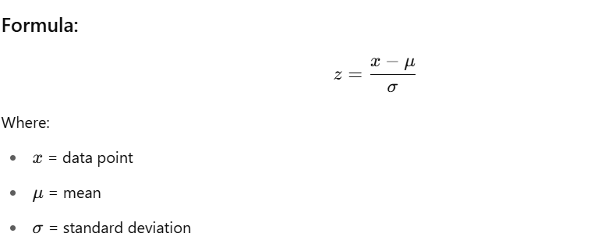

✅ Outlier Criteria (Rule of Thumb)
- If the absolute value of z > 3, it's considered an outlier.
- You may adjust the threshold based on sensitivity, e.g. z > 2.5 for mild detection.

📌 Example:
from scipy import stats
import numpy as np

z_scores = np.abs(stats.zscore(df['column']))
df_outliers = df[z_scores > 3]
📚 Libraries:
- scipy, numpy, pandas
✅ Use Case:
- Normally distributed data (e.g., height, IQ scores)

🔹 2. IQR Method (Interquartile Range)
Outliers lie outside 1.5×IQR (Q1–1.5×IQR or Q3+1.5×IQR)
📌 Example:
Q1 = df['column'].quantile(0.25)
Q3 = df['column'].quantile(0.75)
IQR = Q3 - Q1

df_outliers = df[(df['column'] < (Q1 - 1.5 * IQR)) | (df['column'] > (Q3 + 1.5 * IQR))]
📚 Libraries:
- pandas
✅ Use Case:
- Any numerical feature, especially skewed data

🔹 3. Boxplot Visualization
Used for visually spotting outliers using boxplots.
📌 Example:
import seaborn as sns
import matplotlib.pyplot as plt

sns.boxplot(x=df['column'])
plt.show()
📚 Libraries:
- seaborn, matplotlib
✅ Use Case:
- Exploratory data analysis (EDA)

🔹 4. Isolation Forest (Machine Learning-Based)
Unsupervised ML model that isolates anomalies.
📌 Example:
from sklearn.ensemble import IsolationForest

clf = IsolationForest(contamination=0.05)
df['outlier'] = clf.fit_predict(df[['column1', 'column2']])
df_outliers = df[df['outlier'] == -1]
📚 Libraries:
- scikit-learn
✅ Use Case:
- Multivariate data, fraud detection, network intrusions
Contamination?
The model assumes that 5% of the data are outliers
Isolation Forest does not automatically know how many outliers exist. The contamination parameter:
- Helps the model calibrate the decision threshold
- Tells it how many samples to classify as outliers

🔹 5. DBSCAN Clustering
Density-based clustering algorithm that labels sparse points as outliers.
📌 Example:
from sklearn.cluster import DBSCAN
import numpy as np

db = DBSCAN(eps=0.5, min_samples=5).fit(df[['column1', 'column2']])
df['outlier'] = (db.labels_ == -1)
📚 Libraries:
- scikit-learn
✅ Use Case:
- Non-linear spatial clusters with noise/outliers

1. eps: Epsilon (ε) – Radius of Neighborhood
- Defines the maximum distance between two samples for them to be considered as neighbors.
- Think of it as the radius of a circle drawn around each point.
- Smaller eps → tighter clusters
- Larger eps → looser clusters
🔸 If a point has enough neighbors within this radius, it becomes a core point.

🔍 2. min_samples: Minimum Number of Points in Neighborhood
- Minimum number of points (including itself) required to form a dense region (i.e., a core point).
- If a point has fewer than min_samples within eps, it might be considered noise or an edge point.
✅ Definitions Based on These Two:
Type of Point | Criteria
Core point | ≥ min_samples points within eps
Border point | < min_samples within eps but in the neighborhood of a core point
Noise point | Not in any cluster, not even near a core point

🔹 6. LOF (Local Outlier Factor)
Detects density-based local outliers.
📌 Example:
from sklearn.neighbors import LocalOutlierFactor

lof = LocalOutlierFactor(n_neighbors=20)
df['outlier'] = lof.fit_predict(df[['column1', 'column2']])
df_outliers = df[df['outlier'] == -1]
📚 Libraries:
- scikit-learn
✅ Use Case:
- When outliers are close to each other in dense regions

🔹 7. Quantile Clipping
Cap the values to a given percentile range (e.g., 1st to 99th)
📌 Example:
df['column'] = df['column'].clip(lower=df['column'].quantile(0.01),
upper=df['column'].quantile(0.99))
📚 Libraries:
- pandas
✅ Use Case:
- To mitigate effect of extreme values without dropping

📌 Summary Table
Method | Library | Use Case
Z-score | scipy, numpy | Normal distributions
IQR | pandas | General numeric data
Boxplot | seaborn, matplotlib | Visual EDA
Isolation Forest | scikit-learn | Multivariate anomaly detection
DBSCAN | scikit-learn | Spatial clusters with noise
LOF | scikit-learn | Local density-based outliers
Quantile Clipping | pandas | Keep outliers but reduce impact

What is IQR (Interquartile Range)?
The IQR is a measure of statistical dispersion, or how spread out the values in a dataset are. It helps you understand where the middle 50% of your data lies.
💡 Definitions:
- Q1 (1st Quartile): The value below which 25% of the data falls (i.e., 25th percentile or quantile(0.25)).
- Q3 (3rd Quartile): The value below which 75% of the data falls (i.e., 75th percentile or quantile(0.75)).
- IQR = Q3 - Q1: This represents the middle 50% of your data (between the 25th and 75th percentile).

✅ Why Use IQR to Detect Outliers?
IQR gives a robust view of central tendency that is not affected by extreme values (unlike mean and standard deviation).
Outliers are defined as values that lie significantly outside this middle 50%.

✅ Why Use the 1.5 Multiplier?
This is a standard statistical rule known as Tukey’s Rule:
A data point is considered an outlier if it is:
- less than Q1 − 1.5 × IQR
- greater than Q3 + 1.5 × IQR
Why 1.5?
- It’s a convention, not a strict rule — designed to balance sensitivity and robustness.
- It flags unusually distant values from the central range without being too aggressive.
- Statistically, under a normal distribution:
  - Only ~0.7% of values are expected to lie outside 1.5×IQR.
  - So it works well in practice even for skewed data.
You can use 3 × IQR if you want to catch only extreme outliers, and reduce false positives.

📊 Visual Representation
java
CopyEdit
|--------|========================|--------|
Q1 Q3
|<-- IQR -->|
Lower Bound = Q1 - 1.5*IQR
Upper Bound = Q3 + 1.5*IQR

✅ Python Example for Intuition
import numpy as np

data = [10, 12, 14, 15, 16, 17, 18, 19, 21, 25, 100] # 100 is an outlier

Q1 = np.percentile(data, 25)
Q3 = np.percentile(data, 75)
IQR = Q3 - Q1

lower_bound = Q1 - 1.5 * IQR
upper_bound = Q3 + 1.5 * IQR

print(f"Q1: {Q1}, Q3: {Q3}, IQR: {IQR}")
print(f"Outlier bounds: {lower_bound} to {upper_bound}")

outliers = [x for x in data if x < lower_bound or x > upper_bound]
print(f"Outliers: {outliers}")

✅ When Not to Use IQR?
- For normally distributed data, z-score might be more appropriate.
- For time series data, other techniques like moving averages or seasonal decomposition might be better.

🔁 Recap
Term | Meaning
Q1 | 25th percentile
Q3 | 75th percentile
IQR | Interquartile range (Q3 - Q1)
1.5 * IQR | Threshold for detecting moderate outliers

Proof of the Z-Score Algorithms:

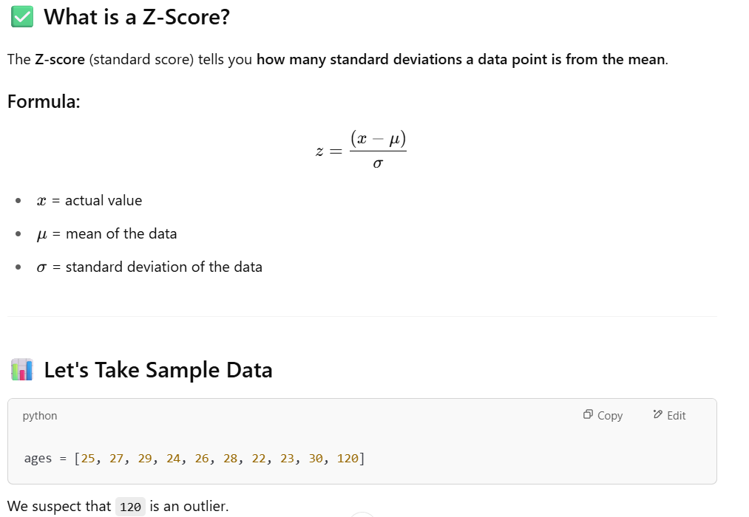

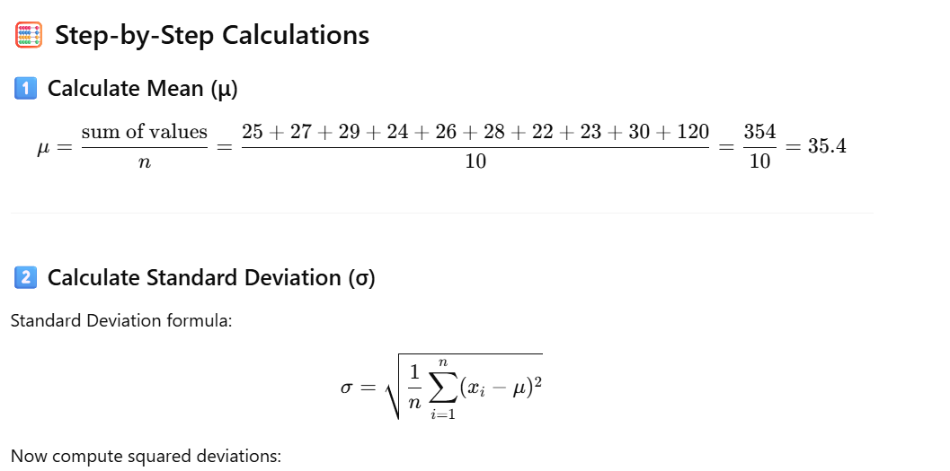
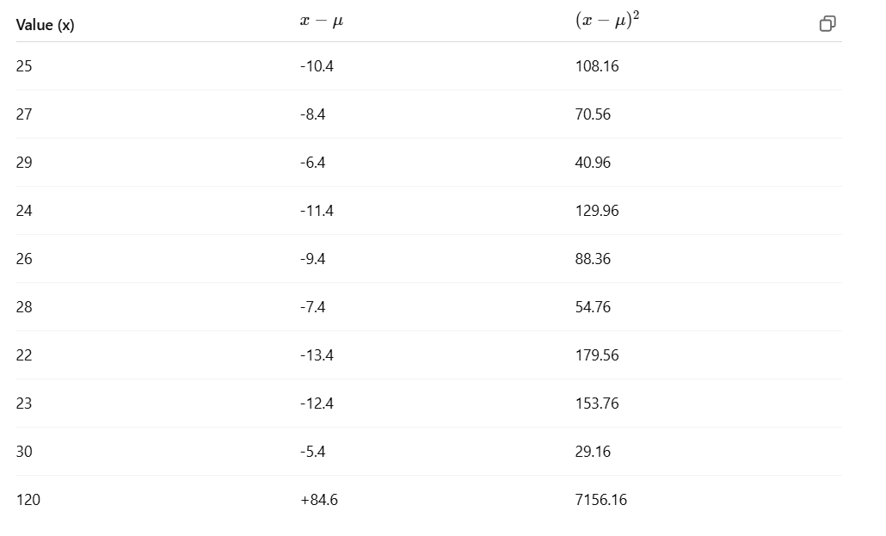
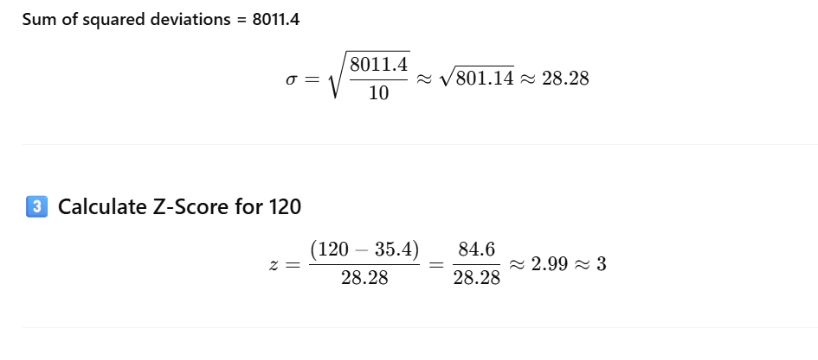
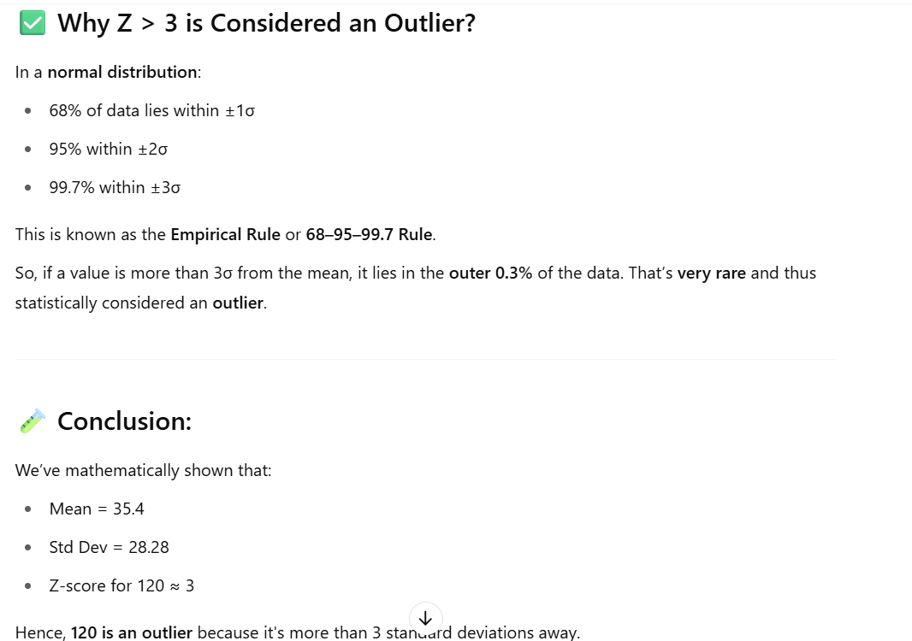

import pandas as pd
import numpy as np
from scipy.stats import zscore
import matplotlib.pyplot as plt

# Step 1: Create a sample DataFrame
data = {
'age': [25, 27, 29, 24, 26, 28, 22, 23, 30, 120], # 120 is an outlier
'salary': [40000, 42000, 41000, 39000, 41500, 43000, 44000, 39500, 40500, 250000] # 250000 is an outlier
}

df = pd.DataFrame(data)
print("Original DataFrame:\n", df)

# Step 2: Calculate Z-scores
z_scores = np.abs(zscore(df))
print("\nZ-scores:\n", z_scores)

# Step 3: Identify rows with any Z-score > 3
outliers = (z_scores > 3).any(axis=1)
print("\nOutlier mask:\n", outliers)

# Step 4: Filter out outliers
df_cleaned = df[~outliers]
print("\nCleaned DataFrame (Outliers Removed):\n", df_cleaned)

# Step 5: Optional - Plot before and after
plt.figure(figsize=(12, 5))

# Original data
plt.subplot(1, 2, 1)
plt.scatter(df['age'], df['salary'], color='red')
plt.title("With Outliers")
plt.xlabel("Age")
plt.ylabel("Salary")

# Cleaned data
plt.subplot(1, 2, 2)
plt.scatter(df_cleaned['age'], df_cleaned['salary'], color='green')
plt.title("Outliers Removed")
plt.xlabel("Age")
plt.ylabel("Salary")

plt.tight_layout()
plt.show()

Can I integrate z-score algo with ML pipeline:

Yes, absolutely! You can and should integrate the Z-score outlier detection method into your ML pipeline — especially in the data preprocessing phase.

✅ Why Integrate Z-score in ML Pipeline?
Removing outliers:
- Helps improve model accuracy and generalization.
- Prevents models (especially linear ones) from being skewed by extreme values.
- Makes normalization/scaling more effective.

🔧 How to Integrate Z-Score into a Scikit-learn Pipeline
There are 2 main approaches:
🔹 Option 1: Manual Preprocessing Before the Pipeline
You compute the Z-scores, remove rows where z > threshold, and then feed the clean data into your pipeline.
import numpy as np
import pandas as pd
from sklearn.pipeline import Pipeline
from sklearn.linear_model import LinearRegression
from sklearn.preprocessing import StandardScaler

# Sample data
df = pd.DataFrame({
'age': [25, 27, 29, 24, 26, 28, 22, 23, 30, 120],
'salary': [50, 52, 53, 51, 49, 54, 45, 44, 56, 500]
})

# Detect outliers using z-score
from scipy.stats import zscore
z_scores = np.abs(zscore(df))

# Remove outliers (z > 3)
filtered_entries = (z_scores < 3).all(axis=1)
df_clean = df[filtered_entries]

# Pipeline
pipeline = Pipeline([
('scaler', StandardScaler()),
('model', LinearRegression())
])

X = df_clean[['age']]
y = df_clean['salary']

pipeline.fit(X, y)

🔹 Option 2: Use a Custom Transformer Inside the Pipeline
This is more reusable and production-friendly.
from sklearn.base import BaseEstimator, TransformerMixin

class ZScoreOutlierRemover(BaseEstimator, TransformerMixin):
def __init__(self, threshold=3.0):
self.threshold = threshold

def fit(self, X, y=None):
return self

def transform(self, X):
z_scores = np.abs(zscore(X))
return X[(z_scores < self.threshold).all(axis=1)]

# Pipeline
pipeline = Pipeline([
('remove_outliers', ZScoreOutlierRemover()),
('scaler', StandardScaler()),
('model', LinearRegression())
])

X = df[['age', 'salary']]
y = df['salary']

pipeline.fit(X, y) # Notice: this may drop rows internally
⚠️ Caveat: If outlier removal affects y, you need to keep track of which rows are removed and apply the same mask to y.

🧠 Use Cases
Use Case | Z-Score Useful? | Notes
Linear regression | ✅ | Outliers heavily impact coefficients
Tree-based models (Random Forest, XGBoost) | ❌ Optional | These are more robust to outliers
Clustering (KMeans) | ✅ | Distance-based; sensitive to outliers
Image/Text classification | ❌ Not required | Often handled by domain-specific preprocessing

Can we integrate IQR outliers in ML pipeline:

Yes, IQR (Interquartile Range)-based outlier detection can also be integrated into an ML pipeline — just like Z-score. It's commonly used in data preprocessing to remove extreme values that may skew model performance.

✅ Why Use IQR in a Pipeline?
- Robust to non-normal distributions (unlike Z-score, which assumes normality).
- Easy to compute using quantiles (Q1 and Q3).
- Works well for numerical tabular data where extreme values are invalid or rare.

🔧 How to Integrate IQR in an ML Pipeline
🔹 Option 1: Manual Preprocessing
import pandas as pd
from sklearn.pipeline import Pipeline
from sklearn.linear_model import LinearRegression
from sklearn.preprocessing import StandardScaler

# Sample data
df = pd.DataFrame({
'age': [25, 27, 29, 24, 26, 28, 22, 23, 30, 120],
'salary': [50, 52, 53, 51, 49, 54, 45, 44, 56, 500]
})

# IQR-based outlier removal
Q1 = df.quantile(0.25)
Q3 = df.quantile(0.75)
IQR = Q3 - Q1

# Keep only rows within 1.5*IQR
df_clean = df[~((df < (Q1 - 1.5 * IQR)) | (df > (Q3 + 1.5 * IQR))).any(axis=1)]

# ML Pipeline
pipeline = Pipeline([
('scaler', StandardScaler()),
('model', LinearRegression())
])

X = df_clean[['age']]
y = df_clean['salary']
pipeline.fit(X, y)

🔹 Option 2: Custom IQR Transformer in a Pipeline
This is the recommended scalable method.
python
CopyEdit
from sklearn.base import BaseEstimator, TransformerMixin
import numpy as np

class IQROutlierRemover(BaseEstimator, TransformerMixin):
def __init__(self, factor=1.5):
self.factor = factor

def fit(self, X, y=None):
Q1 = X.quantile(0.25)
Q3 = X.quantile(0.75)
self.IQR_bounds_ = {
'lower': Q1 - self.factor * (Q3 - Q1),
'upper': Q3 + self.factor * (Q3 - Q1)
}
return self

def transform(self, X):
mask = ~((X < self.IQR_bounds_['lower']) | (X > self.IQR_bounds_['upper'])).any(axis=1)
self.mask_ = mask
return X[mask]

# Create pipeline
pipeline = Pipeline([
('iqr_outliers', IQROutlierRemover()),
('scaler', StandardScaler()),
('model', LinearRegression())
])

X = df[['age', 'salary']]
y = df['salary']

# Apply mask to both X and y
pipeline.named_steps['iqr_outliers'].fit(X)
X_filtered = pipeline.named_steps['iqr_outliers'].transform(X)
y_filtered = y[pipeline.named_steps['iqr_outliers'].mask_]

# Fit remaining pipeline
pipeline.steps = pipeline.steps[1:] # remove custom step
pipeline.fit(X_filtered, y_filtered)

📌 Summary of When to Use IQR vs Z-Score
Criterion | IQR | Z-score
Assumes normal distribution | ❌ No | ✅ Yes
Robust to skewed data | ✅ Yes | ❌ Not robust
Easy to tune | ✅ Yes (factor=1.5 usually) | ✅ Yes (threshold=3)
Ideal for production | ✅ With custom transformer | ✅ With custom transformer

Comparison: Z-Score vs IQR
Feature / Criterion | Z-Score | IQR Method
Assumes Normal Distribution | ✅ Yes | ❌ No (distribution-free)
Best For | Symmetrical, Gaussian (normal) data | Skewed or non-normal data
Affected by Outliers | ❌ Yes (mean and std can be skewed) | ✅ No (uses median and quantiles)
Robustness | Less robust to extreme values | More robust (resistant to outliers)
Intuition | Standard deviation-based distance | Range-based thresholding (middle 50%)
Tunable Parameters | Z-threshold (e.g. 2.5 or 3) | IQR multiplier (e.g. 1.5)
Multivariate Extension | ❌ Not easily extended | ❌ Needs separate handling for each feature
Use in Production Pipelines | ✅ Yes with scaling | ✅ Yes, especially with skewed data
Handling Sparse / Sparse+Skewed Data | ❌ Not recommended | ✅ Recommended

💡 When to Use What?
✅ Use Z-Score When:
- Data is approximately normally distributed.
- You have fewer features or well-scaled data.
- You are fine with distance-based assumptions.
- You want a simple, fast, and interpretable method.
✅ Use IQR When:
- Data is skewed, has heavy tails, or non-normal.
- You're working with real-world messy data (e.g., financial transactions, user behavior).
- You want a robust method that’s not affected by extreme values.

🎓 Summary Table
Data Scenario | Preferred Method
Normally distributed features | Z-Score
Skewed distributions | IQR
Data with many extreme outliers | IQR
Need for intuitive standard scoring | Z-Score
Using Boxplot visualization | IQR

✅ Example Conclusion:
Data Sample | Best Method
Ages of people (normal) | Z-Score
House prices (skewed, heavy outliers) | IQR
Sensor readings (normal, low noise) | Z-Score
E-commerce order amounts | IQR

What is Isolation Forest outlier detection Algo?
Isolation Forest is an unsupervised anomaly detection algorithm that isolates anomalies instead of profiling normal data points.
🔧 How it works:
- Randomly selects a feature and a split value.
- Builds isolation trees (binary trees).
- Outliers get isolated faster → have shorter average path length in the tree.
- Scores each point → lower score means higher likelihood of being an anomaly.

🆚 Comparison: Isolation Forest vs Z-Score vs IQR
Feature / Criterion | Z-Score | IQR Method | Isolation Forest
Type | Statistical | Statistical | Machine Learning
Assumption on Data | Normal distribution | No assumptions | No distribution assumption
Multivariate Detection | ❌ Not ideal | ❌ Hard | ✅ Natively supports multivariate data
Handles High Dimensions | ❌ No | ❌ No | ✅ Yes
Handles Skewed Data | ❌ Poor | ✅ Good | ✅ Excellent
Robustness to Outliers | ❌ Sensitive | ✅ Robust | ✅ Very Robust
Tunable Parameters | Z threshold | IQR multiplier | Contamination rate (expected outlier %)
Supervised Required? | ❌ No | ❌ No | ❌ No (unsupervised)
Interpretability | ✅ High | ✅ High | ❌ Low (black box)
Speed/Complexity | ✅ Fast | ✅ Fast | ⚠️ Slower (tree-based model building)
Best Use Case | Clean, normal data | Small-scale, skewed | High-dimensional, complex, large-scale data

✅ When to Use Each?
1. Z-Score
- Simple, interpretable.
- Use if data is univariate and normally distributed.
- Use in exploratory or real-time pipelines when speed is critical.
2. IQR
- Ideal for univariate skewed data (e.g., income, sales).
- Great for small or medium datasets.
- Visualizable via boxplots.
3. Isolation Forest
- Use for multivariate, high-dimensional, or large datasets.
- Great for fraud detection, network intrusion, complex real-world data.
- Can handle interactions between features that simple methods miss.

